|  |
| --- |
| HND |
| D:\Myint Myat Kaung\2nd year 1st sem Assignment\Untitled-1 copy.PNG**Unit 13: Computing Research project** |
| ***Research-based Project on the remote working***  **May Thet Htar Aung**  Batch –67  2nd year, Second Semester  Assignment  **Start Date : 22.8.2022**  **End Date : 16.9.2022** |



Info Myanmar University

Contents

LO1 Examine appropriate research methodologies and approaches as part of the research process. 5

P1 Produce a research proposal that clearly defines a research question or hypothesis supported by a literature review. 5

Introduction 5

Research Project Proposal 5

P2 Examine appropriate research methods and approaches to primary and secondary research. 12

Research Methodology 12

Quantitative Research 12

Qualitative Research 13

Mix-Methodology Research 13

Research Approach Method 13

Inductive Research Approach 14

Deductive Research Approach 14

Applying Approach Research Method in my Research 15

M1.Evaluate the different research approaches and methodology and make justifications for the choice of methods selected based on the philosophical/theoretical frameworks. 15

The comparison of inducive and deductive research approach 16

The comparison of mix methodology and quantitative and qualitative research method 16

LO 2: Conduct and analyze the research relevant for a business research project. 17

P3. Conduct the primary and secondary research using appropriate methods for a computing research project that considers costs, access and ethical issues. 17

Primary Research 17

Types of Primary Research 17

Secondary Research 17

Apply Research method in this project Research 18

Estimated Cost of this research project 18

Sampling 20

Applying Sampling method in this research project 21

Ethical Issues 21

Explaining of Each this research Survey Questions 22

P4. Apply the appropriate analytical tools to analyze the research findings and data. 25

Applying Microsoft Excel app which Analysis tool for this survey Questions 25

Each Question of Survey Analysis 26

Using Multiple linear Regression in this research project to search the result of this survey 39

M2. Discuss merits, limitations and pitfalls of approaches to the data collection and analysis. 43

Applying Research data collection for this research 43

The advantages and disadvantage of primary data collection 43

The advantage of survey method for data collection 43

The disadvantage of Survey method for data collection 44

Applying research analysis tools for this research 44

The benefits and drawbacks of Google forms for survey questionnaires 44

The benefits and drawbacks of Excel analytical tool 45

The benefits and drawbacks of Regression Analysis 45

The benefits and drawback of Descriptive statistical analysis 46

LO 3: Communicate the outcomes of a research project to the identified stakeholders. 48

P5.Communicate the research outcomes in an appropriate manner for the intended audience. 48

Each conclusion outcome of survey for this project 48

The final outcome for this survey analysis 48

Future solution 49

Stakeholder for research project 49

Difference between Verbal and Nonverbal communication 49

Applying communication methods and skate holder (target audience) in this research project 50

M3.Coherently and logically communicate outcomes to the intended audience for demonstrating how outcomes meet to set the research objectives. 50

LO 4: Reflect on the application of research methodologies and concepts. 53

P6.Reflect on the effectiveness of research methods applied for the meeting objectives of the computing research project. 53

Reflective for my research project by using Kolb’s learning cycle 53

Research methods that used in this research project 55

The effectiveness of this research methods 55

P7. Consider the alternative research methodologies and lessons learnt in a view of the outcomes. 56

Research methods that didn’t use in this research project 56

The alternative research methodologies in this research project 56

The outcomes of this alternative research and methodologies in this research project 56

M4.Provide the critical reflection and insight that results in recommended actions for improvements and future research considerations. 57

The improvements and extending in future for the research 57

Reference 60

Appendix 1 62

Appendix 2 76

Appendix 3 77

Appendix 4 78

Appendix 5 80

Appendix 6 86

Appendix 7 127

Introduction

# LO1 Examine appropriate research methodologies and approaches as part of the research process.

## P1 Produce a research proposal that clearly defines a research question or hypothesis supported by a literature review.

## Introduction

## Research Project Proposal

Student name: May Thet Htar Aung Student number:

Center name :Info Myanmar University Date : 9.5.2022

Tutor : Daw The Nandar Aung and Daw Khayea Aung

Unit : Unit 13: Computing Research Project

Proposed title : Effectiveness of using Microsoft Team in online learning

|  |
| --- |
| **Section One: Title, objective, responsibilities** |
| **Title**  Effectiveness of using Microsoft Team in online learning  **Aim**  This project is aimed at online learning students. In this pandemic situation, most of the students and employees are running the routine daily work based on the online. So, we all are widely using various kinds of a remote working applications. But I just want to use the Microsoft Teams Application for students in remote working. Mainly I want to prove that the various kinds of features and functions of this application has really effective for the students in remote learning.  **Objective**   * To know from the distance education to the online education * To give the valuable information on remote learning area * To investigate the features and function of the Microsoft Teams application * To know the information on how effective Microsoft Teams application for online learning students * To evaluate the strength and weakness of Microsoft Teams in remote learning area * To explain the finding evaluated results and report to particular stakeholders   **Hypothesis**  The Microsoft Teams have the good features which can have positively effects for students in remote working  **Research Question**  Can Microsoft Teams have good features and function for the students in remote working? |
| **Section Two: Reasons for choosing this research project** |
| I chose the Microsoft Teams app for the remote working area project. Because I thought that has all kinds of features in one app. But I aimed for the online learning student for that app. So, I will explain the main features for this app. That was we can do these following functions. There are Teams and channels, Conversations within channels and teams, a chat function, Document storage in share point, online video calling and screen sharing, online meeting, Audio conferencing and Full telephony.  I had a reason why I chose this Microsoft Teams app for the remote working project. Most companies and schools organized their employees and students on remote working because this app had all requirement features and functions. But my school did not use this app. So, I just want to know this app why is widely used and its features and functions. And I think Microsoft Teams has more reliable secure than Zoom application which is using for our online learning system. |
| **Section Three: Literature sources searched** |
| Use of key literature sources to support your research question, objective or hypothesis:  **Paper 1**: Teaching with Teams: An introduction to teaching an undergraduate law module using Microsoft Teams  **Author:** Louis Martin Dave Tapp (Staffordshire University, De Montfort University)  **Abstract:**  Microsoft Teams is a cloud app digital hub that connects Microsoft 365 channels, discussions, meetings, files, and apps. Channels are used to partition a Team into themes or, in this case, undergraduate courses. Teams are made up of channels. The paper combines a practical investigation of Teams as a computer-assisted collaborative learning process with an explanation of what Teams may offer higher education educators. In addition, the study claims that the app's teaching and learning are based on the social constructivism paradigm of educational theory. A social constructivist approach to collaborative learning is discussed in this work. The authors' use of a Team to teach the Language of Law, a module on the LLB degree, is examined in this work. The authors discuss how to use the assignment tab in group workshops to help with PowerPoint presentations, assign required reading, and mark formative assignments.  **Paper 2:** Assessing The effectiveness of Microsoft teams during Covid 19 for online Learning: A student’s perceptive  **Author:** Divyapriya, Research Scholar School of Bio Sciences & Technology, VIT, Vellore-632014, India  **Abstract:** The current COVID-19 pandemic condition has altered the learning platform from the traditional classroom to online learning and teaching style all over the world, thanks to advances in technology. As a result of this situation, educational instructors and students are increasingly turning to online tools and portals like a Zoom, Cisco Webex, Microsoft Teams, Google Meet, and others to expand their knowledge and assist them in achieving their goals. We conducted an examination of Microsoft teams from the standpoint of a bachelor’s degree student in this research page. From a student's perspective, this study reveals that Microsoft Teams is helpful and simple to use for important parts of learning and knowledge acquisition, and it also highlights areas where user-friendliness might be enhanced. As a result, the current study not only aids academics in comprehending the digital utilizing Microsoft Teams as a model, but also provides critical recommendations and proposals for improving such platforms in the future for a better learning experience**.**  **Paper 3:** Teaching with Teams: Microsoft Teams Additional Features Quick Start Guide  **Author:** HITS Learning & Development  **Abstract:** This research was conducted. The University of Kansas Health System and Medical Center was moving from Skype for Business to Microsoft Teams, according to a Microsoft team's guide. Microsoft Teams is a communication platform that includes features including instant messaging, online meetings, screen sharing, and team group messaging. Users will have access to both Skype for Business and Microsoft Teams for the time being, although Microsoft Teams is advised to be used whenever possible. Users can communicate with other users and teams in a variety of ways using Microsoft Teams. |
| **Section Four: Activities and timescales** |
| **Time Estimation Table for the project**     |  |  |  |  | | --- | --- | --- | --- | | **No** | **Activity** | **Estimated Duration** | **Predecessor** | | 1 | **Project Initiation** | 20days |  | | 1.1 | Research the Remote working area | 5days |  | | 1.2 | Choosing the title that related RW area | 3days | 1.1 | | 1.3 | Research the other literature that related title | 10days | 1.2 | | 1.4 | Do the literature review | 12days | | **2** | **Project Planning** | **15days** |  | | 2.1 | Define Research Proposal | 3days | 1.4 | | 2.2 | Draw Work Breakdown Structure | 2days | 2.1 | | 2.3 | Define Time Estimate | 5days | 2.2 | | 2.4 | Draw Gantt Chart | 5days | 2.3 | | **3** | **Examining** | **13days** |  | | 3.1 | Download the application | 1day | 2.4 | | 3.2 | Using/Testing the app features | 6days | 3.1 | | 3.3 | Evaluate the pros and cons of this application | 6days | 3.2 | | **4** | **Data Analysis and Evaluate** | **25days** |  | | 4.1 | Prepare Survey Question | 5days | 3.3 | | 4.2 | Delivery and collect Survey Form | 10days | 4.1 | | 4.3 | Analysis the data from the Survey | 5days | 4.2 | | 4.4 | Evaluate the result | 5days | 4.3 | | **5** | **Completing the project** | **15days** |  | | 5.1 | Project presentation | 5days | 4.4 | | 5.2 | Report project | 6days | 5.1 | | 5.3 | Closing the project | 4days | 5.2 | | **Total Effort Days** | | **88 days** |  | |
| Milestone one: After the project Planning Test  Target date (set by tutor):30.5.2022  Milestone two: After the Data Analysis Test  Target date (set by tutor):4.7.2022  Milestone three: After Evaluate the pros and cons of this application test  Target date (set by tutor): 25.7.2022 |
| **Section Five: Research approach and methodologies** |
| This project research approach is inductive. Because I just want to observe the solution that Microsoft Teams is effective in online education like Remote Working area that was based on survey questions. The inductive approach begins with observations, and theories are proposed as a result of observations near the end of the research process. Inductive research entails looking for patterns in observations and formulating explanations – theories – for those patterns using a sequence of hypotheses. Inductive investigations do not require any theories or hypotheses at the start of the research process, and the researcher is free to change the path of the study once it has begun.  Moreover, I use mix methodology for the research method. Because I have to use Quantitative research and Qualitative research questions. Because some of the questions might be multiple choice or true or false, I need to know some recommendations and feedback from the user, so I have to use short and long questions . For these reasons, I use mix methodology method for this project. |
| **Comments and agreement from tutor** |
| Comments (optional):  I confirm that the project is not work which has been or will be submitted for another qualification and is appropriate.  Agreed: ........................................................ (Name) ...................................................................... (Date) ...................................................... |
| **Comments and agreement from project proposal checker (if applicable)** |
| Comments (optional):  I confirm that the project is appropriate.  Agreed: ......................................... (Name) .................................................................................... (Date) ...................................................... |

## P2 Examine appropriate research methods and approaches to primary and secondary research.

## Research Methodology

The method you intend to implement your research is referred to as your research methodology. This includes how you intend to approach issues such as data collection methods, statistical analysis, participant observations, and so on. Your research methodology can be thought of as a formula. One section will be on how you intend to put your research into effect, while another will be about why you believe this is the best method. In the end, your research technique is a methodological and systematic approach to solving your research problem. In other words, you're describing how you'll take your idea and convert it into a study, which will then yield valid and trustworthy results that are in line with your research's goals and objectives. This is true whether you want to employ qualitative or quantitative methodologies in your paper.

The purpose of this research methodology is to explain why you choose the way you did for your research - you'll need to back up your data gathering methods, analytic methodologies, and other crucial aspects. Consider it as making a plan or an outline for what you want to accomplish. It's easy to get off course or deviate from your normal process when conducting research. A methodology holds you accountable and keeps you on track with your original goals and objectives, as well as providing you with a proper and sound strategy to keep your project on track, seamless, and effective. There are three types of methods, each of which is defined by whether it focuses on words, numbers, or both. There are Quantitative ,Qualitative and Mix Methodology.

### Quantitative Research

Qualitative research entails gathering and analyzing both verbal and textual information. When the research's goal and objective are exploratory, this sort of research methodology is sometimes applied. Observations, interviews and focus groups are quantitative research. Exploratory research can be useful when seeking to understand human behavior, such as in a sociology or psychology study.

### Qualitative Research

This methodology focuses on numerical data measurement and testing.  When conducting this type of research, your goal is usually to verify something. Surveys, tests, existing databases are Qualitative research. If you want to test a collection of hypotheses, for example, you may use this process.

### Mix-Methodology Research

A mixed-method approach incorporates the two methodologies mentioned above. The quantitative strategy will give you  concrete data and numbers, whilst the qualitative methodology will provide a human dimension to your research. When using a mixed-method  approach to research, you can get some really intriguing results. This is the result of testing in a method that produces data that is both precise and exploratory at the same time.

Moreover, I use mix methodology for the research method. Because I have to use Quantitative research and Qualitative research questions. Because some of the questions might be multiple choice or true or false, I need to know some recommendations and feedback from the user, so I have to use short and long questions . For these reasons, I use mix methodology method for this project.

## Research Approach Method

Inductive and deductive research, or inductive and deductive approaches to research, can be thought of as a sort of categorization. These two categories are not interchangeable. Inductive research is primarily concerned with the development of new theories, whereas deductive research is concerned with the verification of existing hypotheses. The primary distinction between the two forms of research is this.

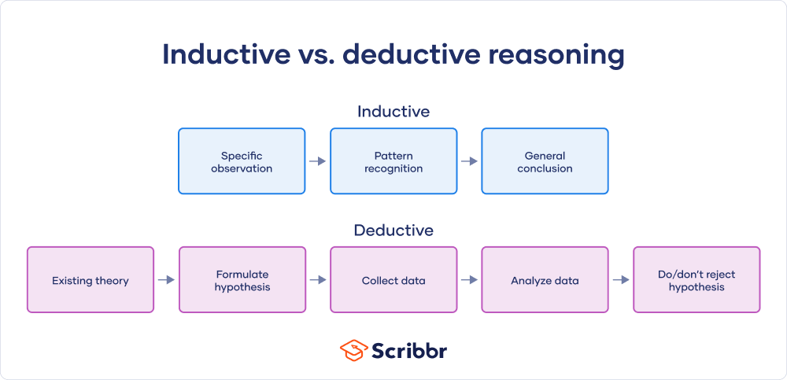

### Inductive Research Approach

The goal of inductive research is to create new knowledge. This usually starts with the researcher's area of interest. The researcher develops research questions and a research topic from the chosen field. He then uses his observations to try to find data. In order to obtain data for his research topics, a researcher can use a variety of research methodologies. This can be done by an interview, observation, or any other means. The researcher strives to find patterns in the data during the analytical step. The researcher creates the hypothesis utilizing his data and found patterns in the final step of inductive research. This demonstrates the use of a bottom-up technique in inductive research. Inductive research is commonly used when there is little or no previous literature on a topic because there is no theory to test. There are three stages to the inductive approach:

* Observation
* Observation pattern
* Develop a theory or general conclusion

### Deductive Research Approach

Deductive research differs from inductive research in that it takes a top-down approach, whereas inductive research takes a bottom-up approach. Deductive research can be defined as a type of research that involves testing a hypothesis in order to confirm a theory. Deductive research, unlike inductive research, tries to test a theory rather than develop new information through the creation of theories.

It makes no attempt to detect patterns in data, instead relying on observation to confirm the pattern. This is primarily used by researchers to disprove beliefs. In quantitative research, the deductive technique is most commonly used to uncover causality and offer a statistical analysis. This emphasizes the differences between inductive and deductive research and how they can be used depending on the researcher's goals. Always start with a theory when conducting deductive research (the result of inductive research). Deductive reasoning is used to test these theories. You can't perform deductive investigation if there isn't yet a theory.

The four steps of deductive investigation are as follows:

* Start with an existing theory
* Formulate a falsifiable hypothesis based on existing theory
* Collect data to test the hypothesis
* Analyze and test the data
* Decide whether you can reject the null hypothesis

## Applying Approach Research Method in my Research

This project research approach is inductive. Because I just want to observe the solution that Microsoft Teams is effective in online education like Remote Working area that was based on survey questions. The inductive approach begins with observations, and theories are proposed as a result of observations near the end of the research process. Inductive research entails looking for patterns in observations and formulating explanations – theories – for those patterns using a sequence of hypotheses. Inductive investigations do not require any theories or hypotheses at the start of the research process, and the researcher is free to change the path of the study once it has begun.

# M1.Evaluate the different research approaches and methodology and make justifications for the choice of methods selected based on the philosophical/theoretical frameworks.

## The comparison of inducive and deductive research approach

Deductive doesn't give any new knowledge. It is a method of verification and instruction. But Inductive can gave new knowledge. And then it is a method of discovery and teaching. Moreover, Deductive is a child gets ready-made information and makes use of it and then it is a quick process and encourages dependence on other sources. But Inductive is that child acquires first-hand knowledge and information by actual observation. And then It is a slow process that trains the mind and gives self-confidence and initiative. After that Deductive is less scope of activity in it and it is a downward process of thought and leads to useful results. But inductive is full of activity and is an upward process of thought and leads to principles. So that my project is matched with the inductive method approach. So that was a reason I chose inductive research approach for my project.

## The comparison of mix methodology and quantitative and qualitative research method

Mix method research is a combination of quantitative and qualitative data to explore research issues and questions. And then it represents a pragmatic or non-paradigmatic research stance. After that, it comes qualitative and quantitative data collection and analysis techniques. The data collection process could be simultaneous, sequential or embedded. The purpose of mix method is that provides greater insight, enables triangulation and complementarity. The qualitative is also that provides understandings and description of participants experience. then the quantitively is that tests and validates already developed theories. Moreover, I will explain the strategies employed of these three methodic mix method, we uses both qualitative and quantitative strategies. In qualitative , that is phenomenology, grounded theory, ethnography, case study and narrative. But In quantitative that use survey and experiment. After that, The method employed of qualitative is open ended questions, observation. And then Qualitative is closed ended questions and numeric data. The mix methodology is pluralistic methods from both approaches. The main reason of why I chose mix methodology for my project is I had to do questionaries with this two type of open questions and closed questions on my survey. By using this two method, I will get the data what I wanted for my survey and research project.

# LO 2: Conduct and analyze the research relevant for a business research project.

## P3. Conduct the primary and secondary research using appropriate methods for a computing research project that considers costs, access and ethical issues.

### Primary Research

Primary research is defined as research that involved gathering unique data that was exclusive to a given research project. When conducting primary research, the researcher collects data directly from sources rather than relying on material that is already available in databases and other publications. Primary research is sometimes known as original research since it is frequently conducted with the intention of generating new information. Researchers hope to provide answers to questions that have never been addressed or even posed. Primary research differs from secondary research in terms of its level of originality. Additionally, unique research is essential for researchers who want to get published in one of the over 40,000 academic publications that are currently available. One of the main requirements for publication is the research's level of originality.

### Types of Primary Research

Primary research can be carried out in a variety of ways, but it frequently applies to the principles of the scientific method . As a result, when performing primary research, researchers create research questions or hypotheses, gather and analyze quantifiable, empirical data, and then come to conclusions based on the facts. The most common types of primary research are

* Survey
* Interviews
* Observation
* Focus of Group
* Data Analysis

### Secondary Research

When conducting secondary research, as opposed to primary research, the researcher summarizes or synthesizes data and literature that has already been collected, edited, and published by others. Researchers use and examine data from primary research sources when conducting secondary research.

Secondary research is frequently employed in a variety of academic and professional sectors, including market and legal research. A systematic review is one of the most used techniques for secondary research in the sciences, for instance. In a systematic review, researchers evaluate all available studies to summarize their conclusions by applying systematic approaches to the existing literature and research on the subject.

When it comes to conducting secondary research, researchers have a lot of options to consider. The sources listed below can help researchers with their secondary research:

* Academic peer-reviewed journals
* Published books and articles
* Government agencies
* Education institutions
* Commercial information sources

### Apply Research method in this project Research

In this Effectiveness of Using Microsoft Team application in online Education’s research, I used the Primary research. Because I have own hypothesis and research questions. My hypothesis is that the Microsoft Teams have the good features which can have positively effects for students in remote working. My research question is that Microsoft Teams have good features and function for the students in remote working? In this primary research, I used survey and data analysis. In survey , I chose that questionnaires which is effective for my hypothesis. And then these data from survey, I did data analysis by using excel tool and Regression, Descriptive , Qualitative and multiple regression.

### Estimated Cost of this research project

**Tangible Cost**

This project is a research project so I used Wi-Fi and its fields for every month are $25 . During this stay home, I can’t meet face , my supervisor. So, I use the zoom meetings so I must buy a zoom license. Additionally, I have to do the presentation in front of my classmates. And when we made the project, we need many things like a laptop or PC, Windows license, Microsoft office license.

|  |  |
| --- | --- |
| Equipment | Cost |
| WIFI | $75 |
| Laptop | $800 |
| Zoom($15 per month) | $45 |
| Microsoft Office ($5 per month) | $15 |
| Windows license | $27 |
| Total Cost | $ |

**Intangible cost**

While I am doing my project. I faced many risks and barriers like electrical problems and so on. When the electricity turns off, I can’t continue forward with my project. SO, I must use mobile data to continue my project but that was always often happened I must buy an inventor battery. When we set up WIFI in our house, we must pay the installation bill. Moreover, the hard disk of my laptop is burnt cause of the heat. Such that I sent this to the service center so I pay the service bill.

|  |  |
| --- | --- |
| Equipment | Cost |
| Mobile data bill | $50 |
| Inventory battery | $25 |
| WIFI installation bill | $25 |
| Service center bill | $50 |
| Total Cost | $150 |

### Sampling

In statistical analysis, sampling is the process of selecting a specified number of observations from a larger population. Depending on the type of study being performed, a variety of methods, including systematic sampling and simply random sampling, may be employed to draw samples from a broader population. There have two types of sampling methods . That is

* Probability
* Non-Probability

**Probability Sampling**

Each sampling in probability sampling has an equal chance of being chosen. A probability sample is one in which each element of the population has a known non-zero probability of selection, according to this definition. The probability that our sample is representative of the population is determined by this sampling method. Some probability sampling methods are as follows;

* Simple Random Sampling
* Stratified Random Sampling
* Systematic Random Sampling
* Cluster Sampling

**Non-Probability Sampling**

Non-probability sampling methodology employs non-randomized ways to draw the sample, in contrast to probability sampling method. The majority of non-probability sampling techniques involve judgment. Participants are chosen because they are accessible rather than at random. For instance, your acquaintances and classmates are more likely to be selected for your sample. Non-probability sampling is not always the best or most convenient way to choose a sample, but in some circumstances, it is necessary and the only option. Some non-probability methods of sampling are as follows:

* Convenience Sampling
* Purposive Sampling
* Quota Sampling
* Snowball sampling

### Applying Sampling method in this research project

I used the non-probability sampling method to survey the research. In this non-probability sampling, I used the convenience method. Convenience Sampling is that subjects are selected because of their convenience, accessibility and proximity to the researcher. Fast, inexpensive, easy and the subjects are readily available.

### Ethical Issues

**Informed consent**

I informed the process of my survey like the number of questions, not sharing your survey with others and you can withdraw consent to participate at any time. And then we did the consent with the writing letter.

**Potentially vulnerable participants**

In this research, I specified fifty participants to survey for my research. But according to my consent, participant will withdraw the consent. So, I should do survey above 60 participants.

**Confidentiality / anonymity**

According to consent, I will don’t share my participants’ survey with any others. I will do the name anonymity of my participants’ names.

**Data storage and security, both during and after the research (including transfer, sharing encryption, protection)**

I will store the data on google drive and laptops. That two all ways have the username and password. When I transfer my file, I will zip the file and encrypt the password to secure my data.

## Explaining of Each this research Survey Questions

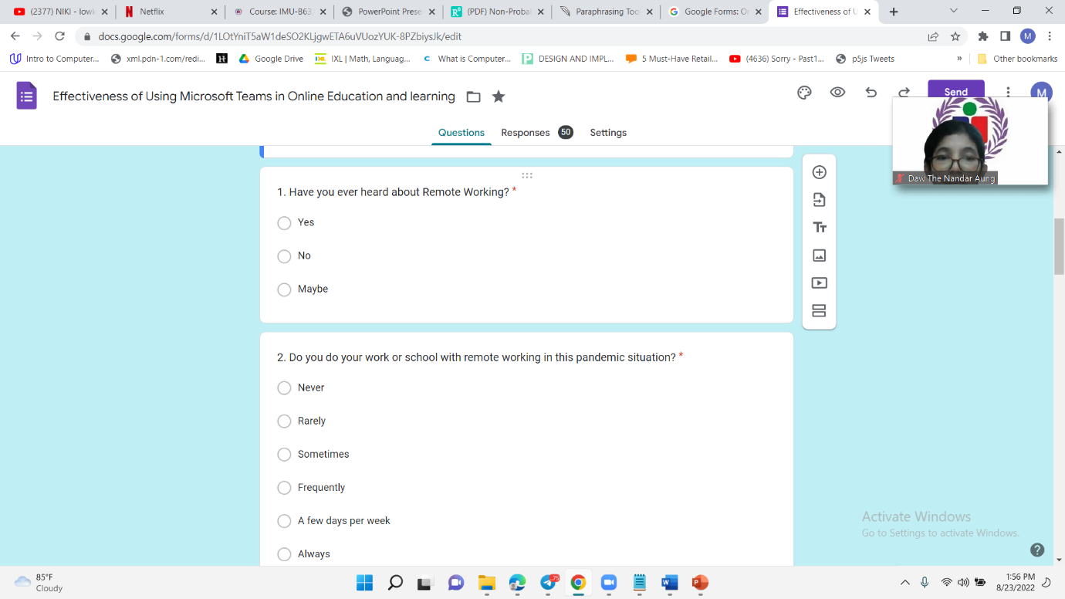

Fig(2.1) Question 1 and 2 of Survey

In this questions 1, if you heard about remote working , you should choose “Yes”. If not, choose “NO”. If you’re not sure, chose “Maybe”. In Question 2, you have to choose the following list if you do work or school with the remote working in this pandemic situation.

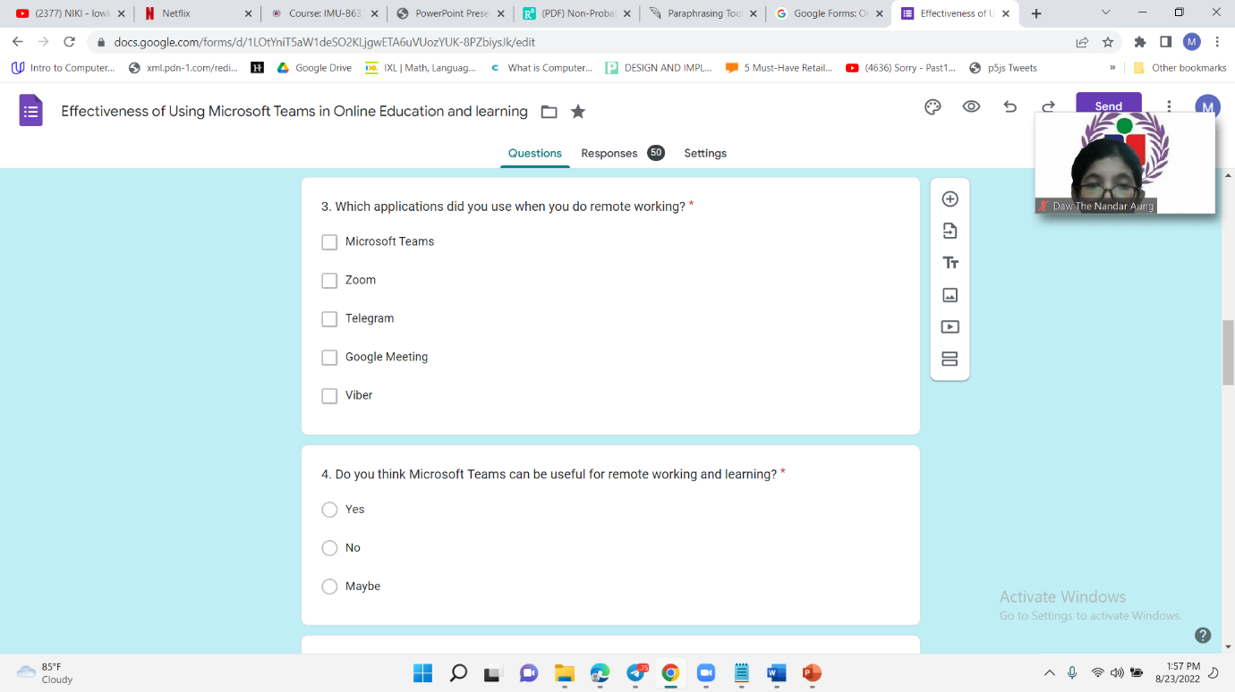

Fig(2.2) Question3 and 4

In Question, you have to choose which application did you use. Question 4 is that just want to about you thought and agreement of this MT application.

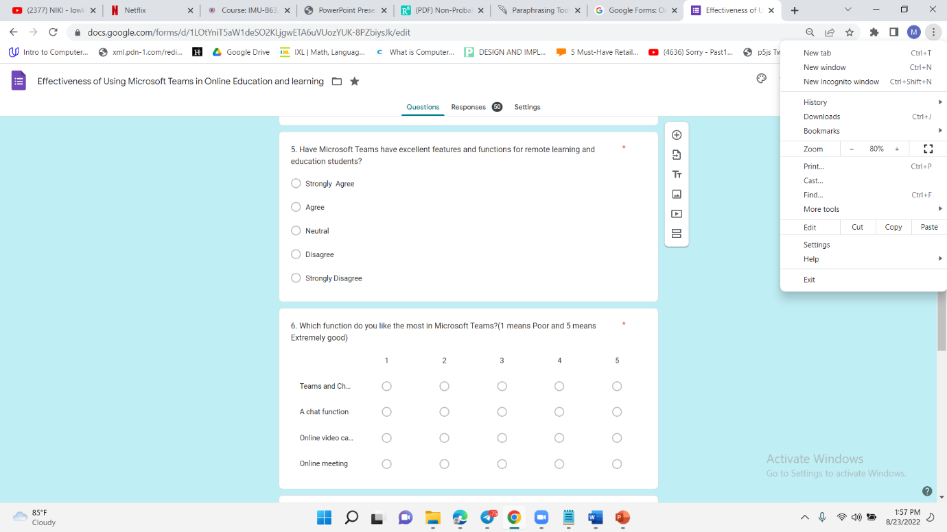

Fig(2.3) Question 5 and 6

In question 5 is my research question and that want to know your opinions of this MT application. In Question 6, give 4 types of function in MT and you need give the rating of each function.

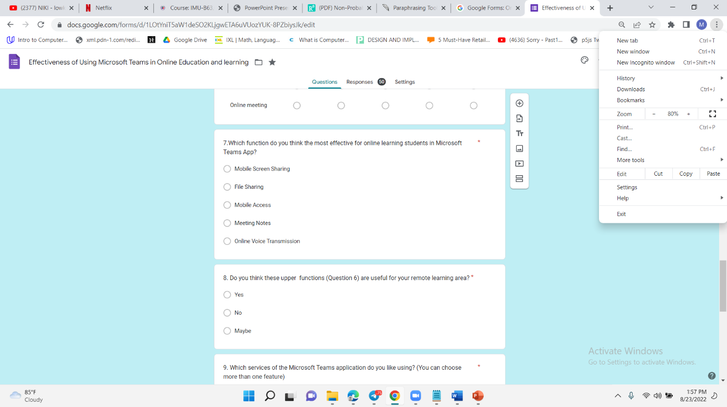

Fig (2.4) Question 7 and 8

In Question7, you have to these functions which is the most effectiveness for online learning students. In Question 8, you have to give an agreement of this upper function are useful in remote learning.

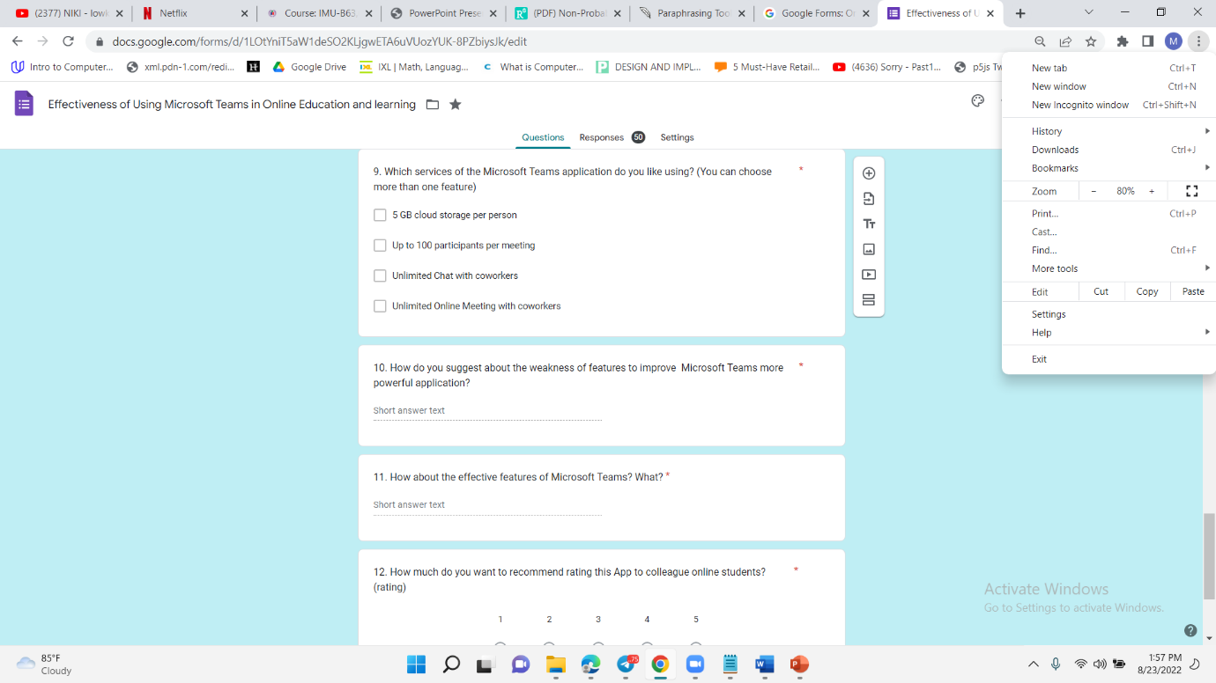

Fig(2.5) Question 9,10 and 11 of Survey

In Question9, you have to choose the following services of this MT app which services is the best. In Question10, you have to give some suggestions of the weakness features in MT app and which tips have to be improved. In Question11 is also like Question 10 but you have to give the effectiveness features of MT app.

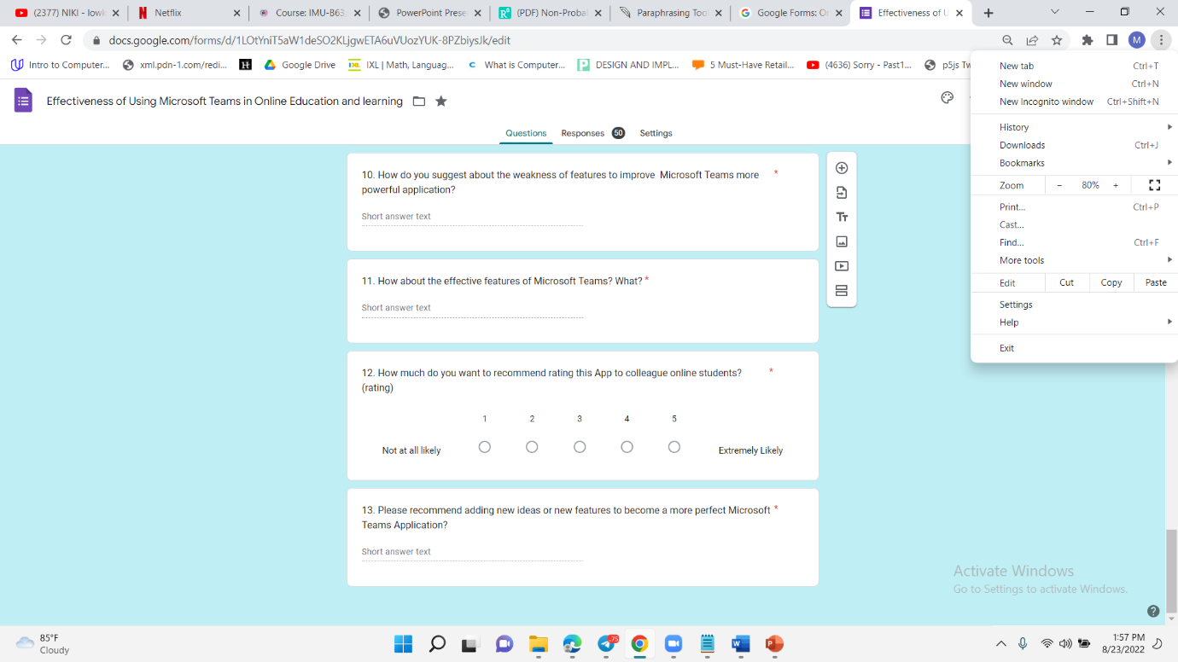

Fig(2.6) Question 12 and 13

In Question12. You have to give the rating of this MT application. In Question 13, you need to give some suggestions of this MT application.

## P4. Apply the appropriate analytical tools to analyze the research findings and data.

### Applying Microsoft Excel and Google Form which Analysis tool for this survey Questions

I chose Microsoft Excel to do data analysis of this survey Question for my research. In this excel, I did analysis each question by using Regression, Descriptive Statistics analysis models . And I also used Frequency Distribution analysis model generated by google forms.

**Microsoft Excel**

Excel is a piece of software developed by Microsoft that makes use of spreadsheets to arrange data and numbers using formulae and functions. Financial analysis is performed by companies of all sizes using Excel analysis, which is widely used worldwide. Excel is frequently used for data organization and financial analysis. It is employed by businesses of all sizes and in all business functions.

**Google Form**

Online software called Google Forms is free and lets you make quizzes, surveys, and other forms of content. It's a component of the Google suite of web-based applications, which also includes Google Docs, Google Sheets, Google Slides, and other tools. It's a flexible tool that can be used for a variety of tasks, including making a pop quiz and collecting RSVPs for an event.

**Regression**

A collection of statistical techniques known as regression analysis is used to estimate the associations between a dependent variable and one or more independent variables. It can be used to simulate the long-term link between variables and gauge how strongly the relationships between them are related.

**Descriptive**

The fundamental characteristics of the data in a study are described using descriptive statistics. Simple summaries of the sample and the measurements are offered. They serve as the foundation for almost all quantitative study of data, along with straightforward graphical analysis

**ANOVA Analysis**

A statistical procedure called Analysis of Variance (ANOVA) is used to examine variations between the means (or averages) of several groups. It is used in a variety of situations to discover whether there are any differences between the means of various groups.

### Each Question of Survey Analysis

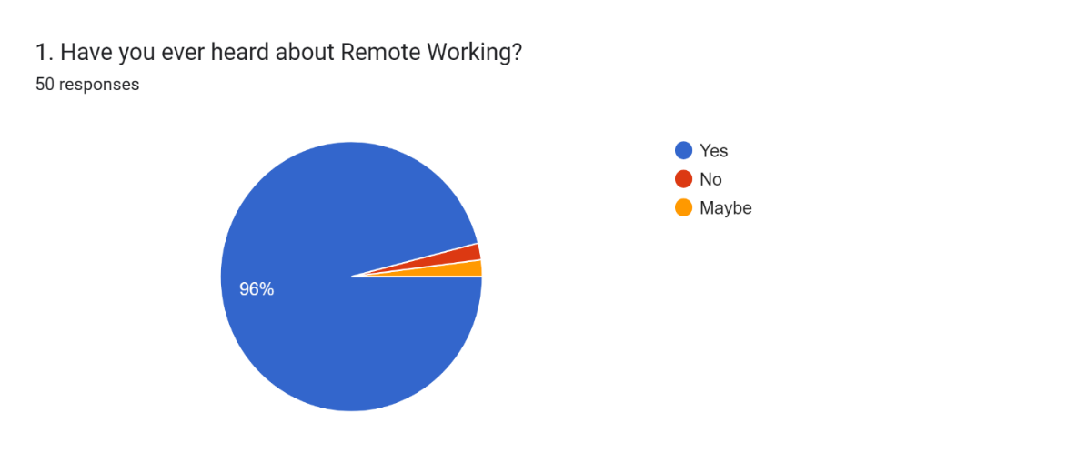

The 96% of people are heard about Remote Working. Each 2% of people are answering “Maybe” and “No”.

|  |  |
| --- | --- |
| Coding Rule |  |
| No | 1 |
| Maybe | 2 |
| Yes | 3 |

|  |  |  |  |  |  |
| --- | --- | --- | --- | --- | --- |
| *1. Have you ever heard about Remote Working?* | Mean | Standard Error | Median | Mode | Standard Deviation |
|  | 2.94 | 0.044355 | 3 | 3 | 0.313635691 |

By Descriptive Analysis : Mode value is 3. Most of the people of heard about the Remote working.

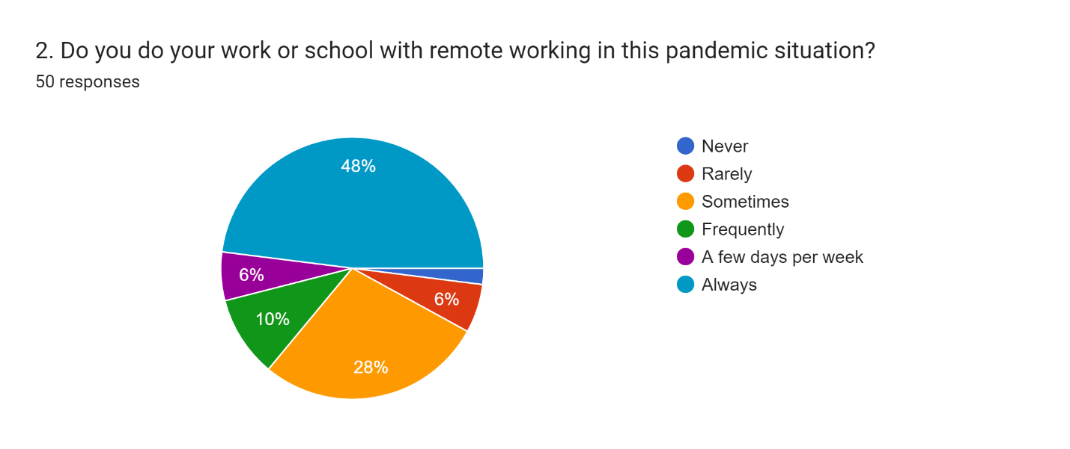

40% of people are answering “Always” use.28% is sometimes.10% is frequently and other 12 % are rarely and a few days per week.

|  |  |
| --- | --- |
| Coding Rule |  |
| Never | 1 |
| Rarely | 2 |
| Sometimes | 3 |
| Frequently | 4 |
| A few days per week | 5 |
| Always | 6 |

|  |  |  |  |  |  |
| --- | --- | --- | --- | --- | --- |
| *2. Do you do your work or school with remote working in this pandemic situation?* | Mean | Standard Error | Median | Mode | Standard Deviation |
|  | 4.56 | 0.219759 | 5 | 6 | 1.553929 |

By descriptive analysis: mode is 6 which means most of the people are always using remote working.

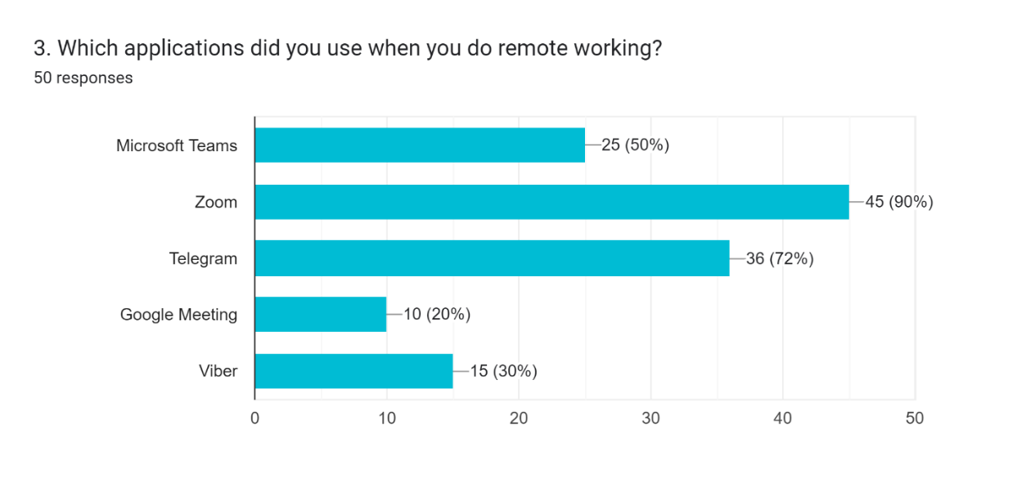

|  |  |  |  |  |  |
| --- | --- | --- | --- | --- | --- |
| 3. Which applications did you use when you do remote working? | | | | | |
|  | Mean | Standard Error | Median | Mode | Standard Deviation |
| *Microsoft Teams* | 0.5 | 0.071428571 | 0.5 | 1 | 0.505076272 |
| *Zoom* | 0.9 | 0.042857143 | 1 | 1 | 0.303045763 |
| *Telegram* | 0.72 | 0.064142698 | 1 | 1 | 0.453557368 |
| *Google Meeting* | 0.2 | 0.057142857 | 0 | 0 | 0.404061018 |
| *Viber* | 0.3 | 0.065465367 | 0 | 0 | 0.46291005 |

In this question: 90% of people are using Zoom application and 72% and 50% of people are using Telegram and Microsoft Teams for remote working and learning . Other 30% and 20% people are using Viber and Google Meeting for their remote working and learning

By descriptive analysis, Mode is 1 in which Microsoft Teams, Zoom and Telegram Application. So, these three application are the most popular in remote working.

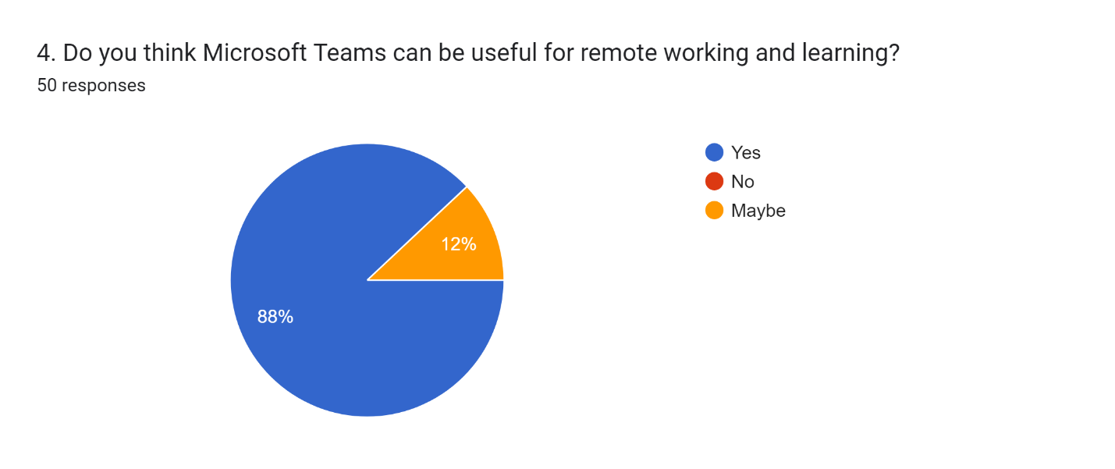

88% of people are answering “Yes” and 20% are “No”. So most of people thought this Microsoft Team is useful for remote working and learning.

|  |  |
| --- | --- |
| Coding Rule |  |
| No | 1 |
| Maybe | 2 |
| Yes | 3 |

|  |  |  |  |  |  |
| --- | --- | --- | --- | --- | --- |
| *4. Do you think Microsoft Teams can be useful for remote working and learning?* | Mean | Standard Error | Median | Mode | Standard Deviation |
|  | 2.88 | 0.046423 | 3 | 3 | 0.328261 |

By descriptive analysis: mode is 3. So most of people thought this Microsoft Team is useful for remote working and learning.

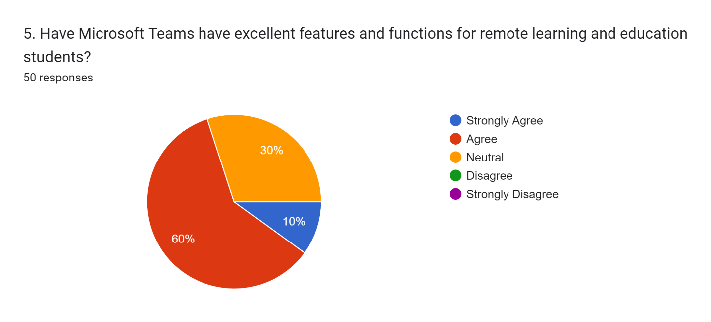

60% of people are answering “Agree” and 30% are “Neutral”. 10% are “Strongly Agree”. So :all of the answer are giving positive answer

|  |  |
| --- | --- |
| Coding Rule |  |
| Strongly Disagree | 1 |
| Disagree | 2 |
| Neutral | 3 |
| Agree | 4 |
| Strongly Agree | 5 |
|  |  |

.

|  |  |  |  |  |  |
| --- | --- | --- | --- | --- | --- |
| *5. Have Microsoft Teams have excellent features and functions for remote learning and education students?* | Mean | Standard Error | Median | Mode | Standard Deviation |
|  | 3.8 | 0.085714286 | 4 | 4 | 0.606091527 |
|  |  |  |  |  |  |

By descriptive analysis: mode is 4. Most of the people answer “Agree” so they thought MTs have excellent features and functions for remote learning and education students.

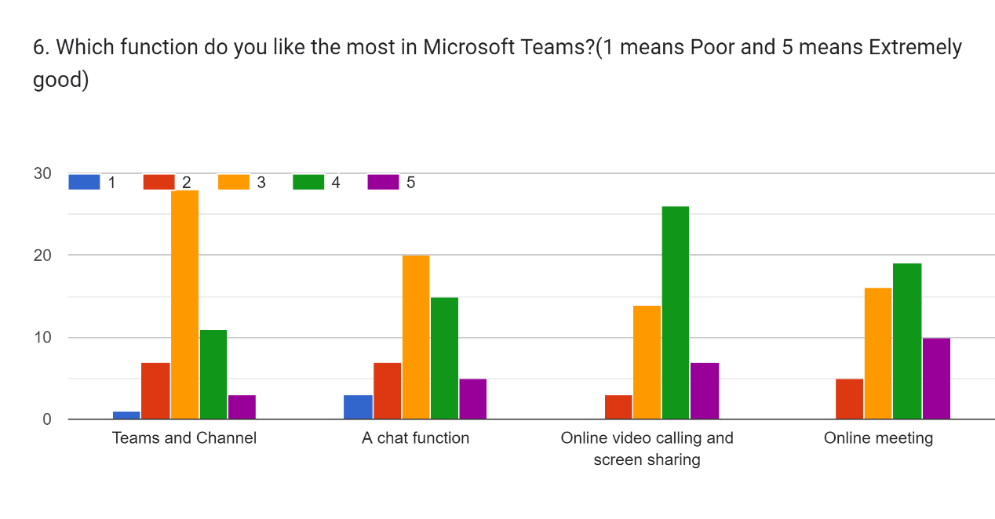

|  |  |  |  |  |
| --- | --- | --- | --- | --- |
|  | Teams and Channels | A Chat Function | Online video calling and screen sharing | Online meeting |
| bad | 2% | 6% | 6% | 0% |
| not bad | 14% | 14% | 6% | 10% |
| normal | 56% | 40% | 28% | 32% |
| good | 22% | 30% | 52% | 38% |
| excellent | 6% | 10% | 14% | 20% |
|  |  |  |  |  |

For Team and Channel features : they gave the rating 2% of bad: 14% of not bad: 56% of normal: 22% of good and 6% of excellent. For a chat function: they gave 6% of bad: 14% of not bad: 40% of normal: 30% of good and 10% of excellent. For Online video calling and screen sharing: they gave 6% of bad: 6% of not bad: 28% of normal: 52 % of good and 14% of excellent. For online meeting: they gave 0% of bad: 10% of not bad: 32% of normal: 38% of good and 20% of excellent.

|  |  |  |  |  |  |
| --- | --- | --- | --- | --- | --- |
| *5. Have Microsoft Teams have excellent features and functions for remote learning and education students?* | Mean | Standard Error | Median | Mode | Standard Deviation |
|  | 3.8 | 0.085714286 | 4 | 4 | 0.606092 |

By descriptive analysis, Mode is 4 so that most of the people are answering agree that Microsoft Teams have excellent features and functions for remote learning and education students.

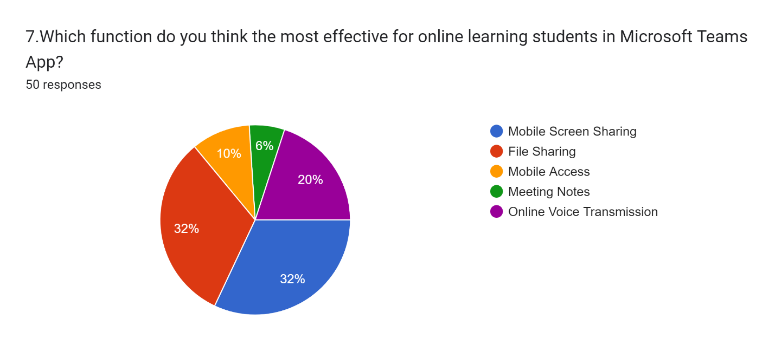

Each 32 % of people are answering “Mobile Screen Sharing” and “ File Sharing”. Other 20%:10% and 6% are answering Online Voice Transmission: Mobile Access and Meeting Notes.

|  |  |
| --- | --- |
| Coding Rule |  |
| Mobile Screen Sharing | 1 |
| File Sharing | 2 |
| Mobile Access | 3 |
| Meeting Notes | 4 |
| Online Voice Transmission | 5 |

|  |  |  |  |  |  |
| --- | --- | --- | --- | --- | --- |
| *7.Which function do you think the most effective for online learning students in Microsoft Teams App?* | Mean | Standard Error | Median | Mode | Standard Deviation |
|  | 2.5 | 0.212372 | 2 | 2 | 1.5017 |
|  |  |  |  |  |  |

By Descriptive analysis: Mode is 2. So: most of the people are answering “File Sharing” that they thought “File Sharing” is the most effective for online learning students in Microsoft Teams App.

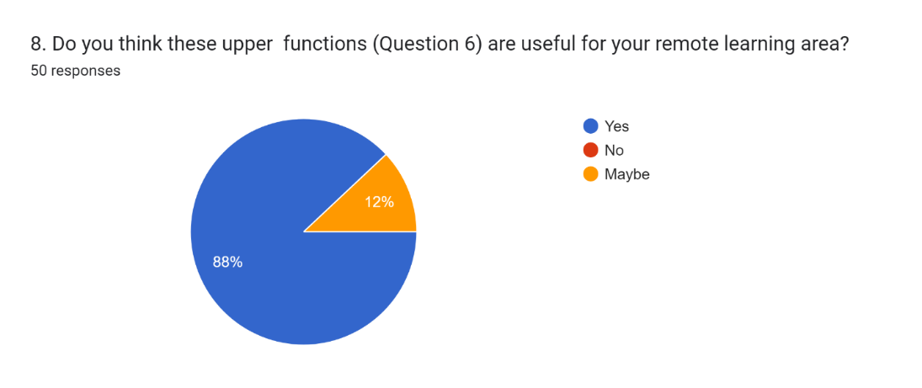

In this question: 88% of people are answering “Yes” and 12% of people are answering “Maybe”.

|  |  |
| --- | --- |
| Coding Rule |  |
| No | 1 |
| Maybe | 2 |
| Yes | 3 |

|  |  |  |  |  |  |
| --- | --- | --- | --- | --- | --- |
| *8. Do you think these upper functions (Question 6) are useful for your remote learning area?* | Mean | Standard Error | Median | Mode | Standard Deviation |
|  | 2.88 | 0.046423 | 3 | 3 | 0.328261 |

By descriptive analysis: Mode is 3.Most of the people are answering “Yes” so that they thought the upper functions are useful for their remote learning area.

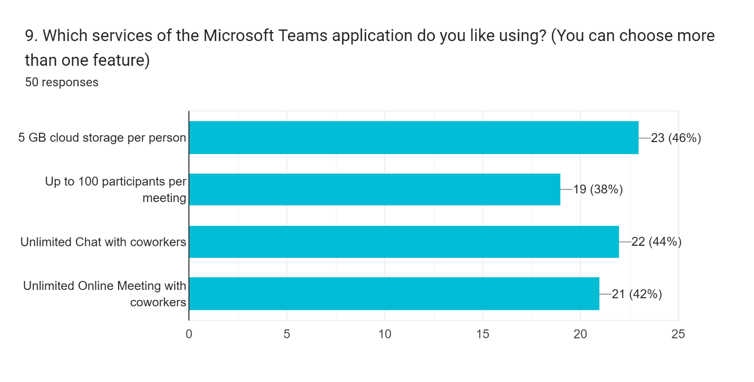

In this question: 46% and 44% of people like using 5 GB cloud storage per person and Unlimited Chat with coworkers of the Microsoft Teams application services. Other 42% and 38% like using Up to 100 participants per meeting and Unlimited Online Meeting with coworkers of this app services.

|  |  |  |  |  |  |
| --- | --- | --- | --- | --- | --- |
|  | Mean | Standard Error | Median | Mode | Standard Deviation |
| *5 GB cloud storage per person* | 0.46 | 0.071199633 | 0 | 0 | 0.503457434 |
| *Up to 100 participants per me* | 0.38 | 0.069340921 | 0 | 0 | 0.490314351 |
| *Unlimited Chat with coworkers* | 0.44 | 0.070912421 | 0 | 0 | 0.501426536 |
| *Unlimited Online Meeting with coworkers* | 0.42 | 0.070508358 | 0 | 0 | 0.498569382 |

10. How do you suggest about the weakness of features to improve Microsoft Teams more powerful application?

By qualitative data analysis: 44% of people are giving No suggestion for the weakness of this app. Each 18% of people are giving limitation and Requirements for the weakness. 12 % and 8% of people are giving System error and interface for the weakness.

|  |  |
| --- | --- |
| Category | Coding |
| No Suggestion | 1 |
| System Error | 2 |
| Interface Design | 3 |
| Limitation | 4 |
| Requirements | 5 |

|  |  |  |  |  |  |
| --- | --- | --- | --- | --- | --- |
| *10. How do you suggest about the weakness of features to improve Microsoft Teams more powerful application?* | Mean | Standard Error | Median | Mode | Standard Deviation |
|  | 2.28 | 0.208082 | 2 | 1 | 1.471359 |

11. How about the effective features of Microsoft Teams? What?

By qualitative analysis: 44% of people are giving No suggestion for the effectiveness features of MTs. 26%:16% and 14% of people are giving Video/Voice/ Screen Sharing features: Other features and functions: and Unlimited Online Meeting for the effectiveness features.

|  |  |
| --- | --- |
| Category | Coding |
| Unlimited Online Meeting | 1 |
| Video/Voice/ Screen Sharing features | 2 |
| Other Features and Functions | 3 |
| No Suggestions | 4 |

|  |  |  |  |  |  |
| --- | --- | --- | --- | --- | --- |
| 11. How about the effective features of Microsoft Teams? What? | Mean | Standard Error | Median | Mode | Standard Deviation |
|  | 2.9 | 0.159719 | 3 | 4 | 1.129384879 |

By descriptive analysis, Mode is 4 which means most of the people didn’t gave the clear suggestion for the effective features of Microsoft Teams.

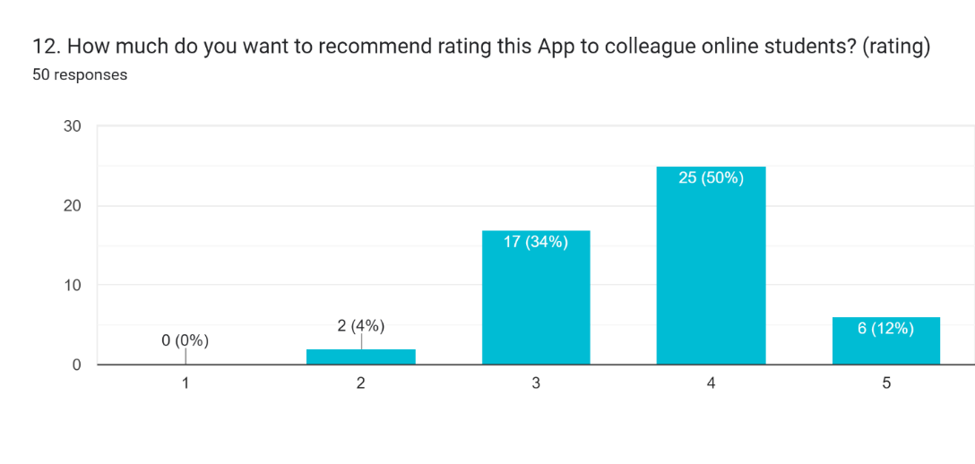

This survey question is for rating this app to colleague online students. 50% of people are giving Good for this app. 24%:12% and 4% of people are giving Normal: Excellent and Not Bad rating for this app. So: Most of the people are giving the Good rating for this app.

|  |  |
| --- | --- |
| Coding Rule | |
| Bad | 1 |
| Not Bad | 2 |
| Normal | 3 |
| Good | 4 |
| Excellent | 5 |

|  |  |  |  |  |  |
| --- | --- | --- | --- | --- | --- |
| *12. How much do you want to recommend rating this App to colleague online students? (rating)* | Mean | Standard Error | Median | Mode | Standard Deviation |
| 3.7 | 0.104002 | 4 | 4 | 0.735402 |

By descriptive analysis: Mode is 4. Most of the people are giving Good rating for this app. So, they think that application is good for other colleagues to do remote learning.

13. Please recommend adding new ideas or new features to become a more perfect Microsoft Teams Application?

By qualitative data analysis: 52% of people are giving No Suggestions for recommendation question.22%:14% and 12% are giving Requirements Function: To do User-friendly and Perfect.

|  |  |
| --- | --- |
| Coding |  |
| Perfect | 1 |
| Requirement Function | 2 |
| To do User-friendly | 3 |
| No Suggestions | 4 |

|  |  |  |  |  |  |
| --- | --- | --- | --- | --- | --- |
| 13. Please recommend adding new ideas or new features to become a more perfect Microsoft Teams Application? | Mean | Standard Error | Median | Mode | Standard Deviation |
|  | 3.14 | 0.151212784 | 4 | 4 | 1.069236 |

By descriptive analysis, Mode is 4 which means most of the people did give the clear suggestion for adding new ideas or new features to become a more perfect Microsoft teams Application.

### Using Multiple linear Regression in this research project to search the result of this survey

After that I did Multiple Regression depends on my Research Question 5. After that I found out two question is depended on this research questions. So that is the Question 6 and 7.

|  |  |  |  |  |  |  |  |  |
| --- | --- | --- | --- | --- | --- | --- | --- | --- |
|  | *Coefficients* | *Standard Error* | *t Stat* | *P-value* | *Lower 95%* | *Upper 95%* | *Lower 95.0%* | *Upper 95.0%* |
| Intercept | 3.490318 | 0.376772 | 9.263744 | 3.56E-12 | 2.732351 | 4.248286 | 2.732351 | 4.248286 |
| 6. Which function do you like the most in Microsoft Teams?(1 means Poor and 5 means Extremely good) [Online meeting] | 0.175705 | 0.087258 | 2.013627 | 0.049794 | 0.000165 | 0.351245 | 0.000165 | 0.351245 |
| 7.Which function do you think the most effective for online learning students in Microsoft Teams App? | -0.13477 | 0.053074 | -2.53921 | 0.014479 | -0.24154 | -0.02799 | -0.24154 | -0.02799 |

According to the regression result, the above two factors of P values are less than alpha variance (0.05) . Therefore, my assumption (my alternative hypothesis) is correct and accepted. There is significantly relationship between my hypothesis and alternative factors.

Y(dependent factor and research question) . Have Microsoft Teams had excellent features and functions for remote learning and education students?

X1(Independent factor ). Which function do you like the most in Microsoft Teams? [Online meeting].

X2( Independent factor) Which function do you think the most effective for online learning students in Microsoft Teams App?

According to the final regression result, Y(dependent factor of my assumption) depends on the X1 and X2 factors (Independent factors).

|  |  |  |
| --- | --- | --- |
| Q5 | Agree | 4 |
| Q6 | Rating (1 to 5) | 5 |

The relationship between the Y and X1 variables is a significantly positive relationship. So, if X1 is increased and then Y also will be increased. For Y dependent variable relationship with X1( independent variable), the actual data value and predicted data value together meet on the trend line (x=5,y=4). In this scatter diagram , x=5 is answered rating number level 5 from 1 to 5 and y=4 is answered agree having excellent features and functions in Microsoft Teams. According to the result of the relationship between Y and X1, the predicted value is (x=5, y=4) is meant that the Microsoft Teams application will be increased with more excellent features and functions using online meetings in the future.

|  |  |
| --- | --- |
| Q5 | Agree |
| Q7 | Mobile Screen Sharing |

The relationship between the Y and X2 variables is significantly negative. So, if X2 is increased and then Y will be decreased. For Y dependent variable relationship with X2( independent variable), the actual data value and predicted data value together meet on the trend line (x=1,y=4). In this scatter diagram, x=1 is answered mobile screen sharing of this MT functions and y=4 is answered agree to have excellent features and functions in Microsoft Teams. According to the result of the relationship between Y and X2, the predicted value is (x=1, y=4) is meant that the Microsoft Teams application will be increased with more excellent features and functions using mobile Screen Sharing in the future.

# M2. Discuss merits, limitations and pitfalls of approaches to the data collection and analysis.

## Applying Research data collection for this research

I did the primary research for my project. For the data collection, I used the survey and questionnaires method. Because In this situation, that was the reliable and suitable method for my research project . Advantages and Disadvantages of the data collection and analytical tools using in this research project are as follows:

### The advantages and disadvantage of primary data collection

While secondary data may or may not be specific to the researcher's goals, primary data is always tailored to those needs. It totally depends on the type of data the researcher was able to obtain. While secondary data may or may not be specific to the researcher's goals, primary data is always tailored to those needs. It totally depends on the type of data the researcher was able to obtain. The expense and effort involved in gathering original data is a drawback, but secondary data may be out-of-date or useless. Because original research involves so many steps and takes so much time, primary data are expensive and time-consuming.

### The advantage of survey method for data collection

The first one is high representative. A large population can be accurately represented by surveys on a general level. The data being collected have a better depiction of the relative features of the general population engaged in the study due to the usual large number of persons who respond to surveys. Surveys can able to collect information that is very close to the precise characteristics of the bigger population when compared to other methods of data collection. And then survey method is also low costs. You just need to pay for the production of survey questionnaires while conducting surveys. On the other hand, more money is needed for researchers to use additional data collection techniques including focus groups and in-person interviews. Moreover, this survey method is also convent data gathering. Participants might well be administered surveys in a variety of methods. Simple email or fax transmission or online administration of the questionnaires are both options. The most widely used method nowadays for getting data from target participants is the online survey method. The most important one is that method is good Statistical Significance. Identifying statistically significant results using the survey approach is frequently simpler than using other data collection techniques because of the high representativeness it produces. Surveys can also be used to analyze many factors successfully.

### The disadvantage of Survey method for data collection

I used this method but I seek some problems while doing this research. The first one is inflexible Design. The survey that the researcher has been using since the beginning, as well as the way it was administered, cannot be changed at any point during the data collection process. Although the survey method's rigidity can be seen as a weakness, it can also be a positive given that the study can be conducted with both accuracy and fairness. And then the next one is Not Ideal for Controversial Issue. Because Participants may not give accurate answers to controversies-related questions because to the likely difficulty of recalling the relevant information. The reality behind these controversies might not be revealed as clearly as it would be if focus groups and face-to-face interviews had been used instead of other data collection techniques. The final one is Possible Inappropriateness of Questions . Survey questions are usually standardized before being given to the participants. As a result, the researcher is compelled to design questions that can be answered by most people. These broad questions, though, might not apply to all the participants as much as they ought to.

## Applying research analysis tools for this research

I used to collect data for my research by using a google survey form. This google form shows the pie bar and bar chart for Some of the questions. Therefore, I want to explain the advantages and disadvantages of analyzing the data by using this google form and excel. In this excel, I was using the Regression and Descriptive analysis. So that , I just want to explain each analysis tool of this benefits and drawbacks.

### The benefits and drawbacks of Google forms for survey questionnaires

It is a free web application that enables quick and effective information gathering. You can quickly build surveys using Google Forms to gather feedback about your goods or services from customers or partners The user interface is fairly simple. Using this tool, any person with a basic understanding of the Internet may develop forms. Utilizing the assistance is straightforward. Drag and drop form elements and event-based organization are made simple by the What-You-See-Is-What-You-Get interface. At the design level, you can decide whether to use your photographs as the background or a color scheme. We can thoroughly analyze the input we receive because Google forms stores it. We can see a spreadsheet view of the information gathered because the forms are connected with Google spreadsheets. You can gather the recipient's email address and set a restriction on the answers thanks to the way that surveys and forms are often configured. The type of data that can be entered into a field can be tailored by experienced users using regular expressions. This makes the form even more individualized. Before submitting the survey to the respondents, we may preview it using Google Forms. We can use any method to distribute the form, including email, website integration, social media, and other channels. So theses are the benefits of google forms for survey.

To use this program, you must have access to the internet. There is relatively little room for design customization. Advanced users can modify the design of the tool to use it for a wider range of objectives. Some people have security issues. To strengthen security, the user must set a strong password and protect it. Regarding this tool's capabilities, there are certain restrictions. Texts up to 500 Kb, photos up to 2 Mb, and spreadsheets with 256 cells or 40 sheets are all acceptable. These are the drawbacks of google forms for survey.

### The benefits and drawbacks of Excel analytical tool

Excel is a tool that may be used for analysis and decision-making. It enables professors to number the grades on a spreadsheet, which students can access to see their exam and quiz results. Excel allows you to share large amounts of data via email or print it out exactly as it appears on the computer. Most cellphones can also view Excel files, making it more convenient. For added security, Excel files can be password-protected. The user can set a password using Visual Basic programming or directly in the Excel file. Excel is also capable of connecting directly to OLAP databases and can be used with Pivot Tables. These are the benefits of Excel analytical tool.

Using just one file can make the file size very large and the software operate slowly, so you might have to split it into multiple files, increasing the chance of Excel data loss. The viruses can be attached to an Excel file through macros, which are little programs written into an Excel spreadsheet. That is the drawbacks of Excel.

### The benefits and drawbacks of Regression Analysis

Since regression models are based on fundamental statistical concepts like correlation and least-square error, they are simple to comprehend. Regression models produce an algebraic equation that may be used to make predictions and is simple to comprehend. The strength (or goodness of fit) of the regression model is assessed using the correlation coefficients and other closely related, well-understood statistical characteristics. Regression models' predicting abilities are comparable to those of other predictive models, and they occasionally outperform their rivals. Regression models have the flexibility to include any and all variables. Tools for regression modeling are widely used. Regression tools are included in nearly all statistical software for data mining.

If the supplied data contains errors, regression models will not function effectively (that is poor quality data). The reliability of the regression model is compromised if the data preparation is not done correctly to exclude missing values, redundant data, outliers, and unequally distributed data. Regression models can have collinear issues (that is there exists a strong linear correlation between the independent variables). Strong correlation between the independent variables reduces their ability to predict each other and weakens the robustness of the regression coefficients. Regression models become less accurate as the number of variables rises. If there are fewer variables, the regression models function more effectively.

### The benefits and drawback of Descriptive statistical analysis

We can display the data visually with descriptive statistics. Visual data presentation makes information much simpler to comprehend. Pie charts and bar charts can be used to display qualitative data. The presentation of numerical data might take the shape of histograms or dot plots. We can highlight the key features of the data using the various statistical metrics. The mean, for instance, assesses the data values' central tendency. This gives us a general idea of the distribution of the data values. When working with a huge amount of numerical data, this is crucial. The metrics of dispersion, such the standard deviation, assist us in determining how widely apart the data values are from each other. So that are the benefits of DS analysis.

Based on the provided data values, descriptive statistics cannot be used to create any form of prediction. Regression analysis is one of the inferential statistics procedures that enables us to forecast future values of the variable. The process of gathering data typically takes time and money. For instance, conducting surveys to gather data is labor-intensive. The survey's interviewers must be trained and paid; therefore, it is a time-consuming and expensive operation. The audience can be duped and given a false impression through the misuse of descriptive data. For instance, a layperson who is untrained in statistics may draw incorrect conclusions by merely changing the scale of a graph. So that are drawbacks of DS analysis.

### The benefits and drawbacks of frequency distribution analysis

The data are presented in a more condensed manner. At first glance, one can have a greater understanding of the key elements of the data. The distribution of observations into different classes can be immediately observed. It enables the application of more sophisticated statistical methods that aid in the discovery of various additional obscure and hidden properties of the data. We may create histograms, bar graphs, and other diagrams that will aid us in visualizing the data by using the frequency distribution table. These are all the benefits of frequency distribution analysis.

The individuality of individual observations is lost throughout the grouping process. It becomes challenging to observe the distribution of the observations within each class. This is more relevant to frequency distributions created by the tally approach. This type of grouping has a severe flaw in that if there are too few classes, there will be an excessive amount of observations clustered together in different classes. Some of the crucial information will therefore go undiscovered as a result. So it's crucial that summarizing information doesn't mean leaving out crucial information. Finding a good middle ground between providing too few and too many details should be the goal. These are all the drawbacks of frequency distribution analysis.

# LO 3: Communicate the outcomes of a research project to the identified stakeholders.

## P5.Communicate the research outcomes in an appropriate manner for the intended audience.

## Each conclusion outcome of survey for this project

Q1: 96 % of people heard about Remote working and learning. So That result is good for my hypothesis.

Q2: 48% of people are always used for their school and work in this pandemic situation. That was also a good result for my hypothesis.

Q3:50% of people used when they do remote working and learning. So That result is also good.

Q4: 88% of people thought that the Microsoft team can be useful for remote working and learning.

Q5: 60% and 10% answered agree and strongly agree that the Microsoft team have excellent features and functions for remote learning and education students.

Q6: they gave the over 50% in good for the features of Microsoft Teams.

Q7: they thought File Sharing and Mobile sharing are the most effective function for online learning students in Microsoft Teams.

Q8: 88% of people thought that the upper functions are useful for remote learning areas.

Q9: 46% of people liked the 5GB cloud storage per person service of Microsoft Teams.

Q10: 56% of people give suggestions about the weak features to improve Microsoft Teams.

Q11:56% of people give suggestions about the effective features of Microsoft Teams.

Q12:50% and 12% of people gave a good and excellent rating for this application to recommend to other colleague online students.

Q13: 48% of people gave the recommended for this application.

## The final outcome for this survey analysis

As this survey analysis, the outcome is matched with my hypothesis. Because most of them gave me the feedback that MT application was effectiveness for online education and effectiveness. Moreover, most of this application’s user liked the mobile screen sharing and online meeting of this app. Therefore, my assumption (my alternative hypothesis) is correct and accepted. There is significantly relationship between my hypothesis and alternative factors.

## Future solution

Some of the audiences gave me the feedback what that application needs to add some features , system maintenance , security and user interfaces. And then I will explain the detailed point of suggestion for this app. That is MT app needs to take more marketing and attraction to use for user. And MT also have to do Group voting feature to support decision. Moreover, We have to prepare that was to Make the chats searchable and send and filter messages using @mention. But Most of the people gave the suggestion that was MT application’ s user interface is so complexing for them. Therefore, I have to prepare this requirement of this application to be effectiveness for online learning students and education.

## Stakeholder for research project

Stakeholders are individuals or groups that are interested in, have an impact on, or are impacted by the findings of a research study. Stakeholders include people who are in favor of your research as well as those who may be against it or perhaps have negative opinions about it. The purpose of stakeholder analysis is to:

* identify project stakeholders
* determine what interest each stakeholder has in your project.
* assess how much influence stakeholders have on the project.
* consider how you will manage and communicate with different types of stakeholder.

## Difference between Verbal and Nonverbal communication

|  |  |  |
| --- | --- | --- |
| Category | Verbal Communication | Non-Verbal Communication |
| Definition | The communication in which the sender makes use of words, whether spoken or written, to transmit the message to the receiver is recognized as verbal communication | The communication that takes area between sender and receiver with the use of signs and symptoms is recognized as no verbal communication. |
| Types | Formal and informal | Chronemics, Cocalico, Haptics, Kinesics and proxemics |
| Time Consuming | NO | Yes |
| Chances of transmission of wrong messages | Rarely happens. | Happens most of the time |
| Documentary Evidence | Yes, in case of written communication | No |
| Advantage | The message is understood and interfered, and immediate feedback is workable | Understanding the sender’s emotions, status lifestyle and feelings is aided by this information. |

## Applying communication methods and skate holder (target audience) in this research project

In this research, we have to do many communication with my target audience, supervisors and who used this MT app in remote learning. So that I used many types of communication. So that I just want to explain about of the communication. In communication, there have two types. That was the verbal and non-verbal communication. In verbal communication also have formal and informal communication. In this research project, mostly I used formal languages because of my supervisor and target audiences. For my supervisors, I have to present my project by using presentation slide and zoom meetings. At that time, I need to use the formal languages. Moreover, when I collected data with the survey form from the target audience, I used the formal written communication. I will invite some stakeholders as my target audiences in order to make my presentation to explain about finding results, who are my supervisors and some interested persons related with IT fields. When I invite them, I used to communicate using messenger, telegram.

# M3.Coherently and logically communicate outcomes to the intended audience for demonstrating how outcomes meet to set the research objectives.

Before demonstrating the outcome, Firstly I will explain my objectives for my research project ( Effectiveness of using Microsoft Teams in online learning and Education). These objectiveness are

* To know from the distance education to the online education
* To give the valuable information on remote learning area
* To investigate the features and function of the Microsoft Teams application
* To know the information on how effective Microsoft Teams application for online learning students
* To evaluate the strength and weakness of Microsoft Teams in remote learning area

The first objective the to know from distance education to online learning education. In this pandemic, most people use technical apps in their remote learning and working. So, The Microsoft team's application is also one of the technical apps for remote learning and working that people used app by this survey research’s outcome. That remote working and learning area are more popular because of the pandemic. Before pandemic, 21st century people aren’t strange with this technical apps. But they didn’t know how that we called like remote learning and working. I was also known about that area by doing this research.

The second objective is the to give the valuable information on remote learning area. By doing this research survey’s result and outcome. Most of the people have also the basic knowledge about this remote learning area. But I asked and delivered my survey to the friends that are already familiar with this area. So that would be the reason and to get the outcome from my survey. But I believe some of the people who doesn’t know about remote learning and working area, who they will get a lot of information by answering and researching from my research project.

The third objective is the To investigate the features and function of the Microsoft Teams application. By doing this research, I had known about the almost features and function of this app, Some function and features are really great for remote learning students and working employees. In my survey, I also show about the features and function of this app. So, 80% of people are using this features and functions and they thought that are suitable for them. But Some of my opened question that reliable features and function questions, I got some result and outcome about the features and function of this app. Some of them are reported me, you should add some features for grouping project. And then the basic user also just want to get the user-friendly interface for them.

The four objective is the To know the information on how effective Microsoft Teams application for online learning students. So that was also my hypothesis. I added the research questions that was reliable with my hypothesis on my survey. On this questions, 70% of people are agreed with this survey. But 30 % are also that gave me the neutral result for this questions. So that, that result and outcome is matched with this objective.

The final objective is the To evaluate the strength and weakness of Microsoft Teams in remote learning area. For this objective, I did the open questions in this survey research. 56 % of people gave me what the strength is in This application. Some of them didn’t answer well because of the open questions. But I got the detailed about of the strength of this app. And the 56% of people also gave me what the requirements and weakness of this app. So I can evaluate the strength and weakness of MT in remote learning area because of this result and outcomes. And then I presented that is equal and matched with the results of this research and my hypothesis to the supervisor and the intended audiences .

# **LO 4: Reflect on the application of research methodologies and concepts.**

## P6.Reflect on the effectiveness of research methods applied for the meeting objectives of the computing research project.

## Reflective for my research project by using Kolb’s learning cycle

My project title is the Effectiveness of using Microsoft Teams in online learning.This project is aimed at online learning students. In this pandemic situation, most of the students and employees are running the routine daily work based on the online. So, we all are widely using various kinds of a remote working applications. But I just want to use the Microsoft Teams Application for students in remote working. I want to prove that this app has various kinds of features and functions that are effective for the student in remote learning. My accomplish and hypothesis is Microsoft Teams have the good features which can have positively effects for students in remote working. I guessed my project is succeeded in its aim. Because when I did the questionaries survey , I got the data and information for my questionaries. After that, I did data analysis for each question. Over 50% of people are agree with my study.

For this project, I worked well on these 5 steps. That is the project initiation, Project planning, Data Analysis, Examining and Completing the project. Each task has other tasks. So, I will explain this all tasks and how to work well by using Kolb’s learning cycle in reflective writing.

The first step of Kolb's learning cycle is Experience. In this project, I worked on many things. During the project initiation, I did Research on the remote working area, Chose the title that related RW area, researched the other literature that related to my title and do the literature review. In those task, I researched about many remote working area and chose the title for my project. After that, I had to do the literature review for my project related title. I didn’t know about how to do literature review but I did well by our supervisors’ help and from the other literature review. In the project planning task, I did the project proposal after literature review. At that time , I already known well what is my project’s aim and objectives. Then I did the time management and dividing the task by using Work Breakdown Structure, Time estimation and Gantt Chart. In this Gantt , I divided the milestones for the project. While doing this tasks, I prepare many times to match the estimated time with the tasks. In this examining tasks, I tested my application and then evaluated what is the pros and cons of this applications. Moreover, I also did Prepare Survey Question, Delivery Survey form, Analysis the data from the Survey and Evaluate the result. And then in the data analysis tasks, I prepared the questionaries and delivered the survey to the friendly technology colleagues and friends. All done this project tasks, I did the analysis for my project. Most of the people are giving the positive feedbacks of my research project. And they point out what is the requirement of this application for the online education students. When we add the requirements, this application is perfect and effective for online learning students. The final task is completing the project . But it didn’t finish yet. Now I’m doing project performance for the whole project by using Kolb’s learning cycle reflective writing.

The second step of Kolb’s learning cycle is reflective . While I am doing this project, I didn’t know about the remote working although I was using it. In this project Initiation tasks, I got many knowledge from the remote working area. After that, I thought the aim and objectives for my project in a short time. That was really stressed me out. But I overcame by our supervisor’s help. And then I did time management by using those of things. But those things are friendly in MSCP subject so I didn’t have many problems. After that I did the testing my chosen application , but this application is already friendly with me so I already known about what is pros and cons for students. Thus, in this examining task, I didn’t have many obstacles. Furthermore, In this data analysis task, I did many times to get the right questionaries and to match with my hypothesis. I gave a long time than I expected. And then, I did the data analysis for my collected data by using many analysis methods. After the analysis, I got the answers that I expected.

The third step of Kolb’s learning cycle is a conceptualize. In this project initiation , planning and data analysis tasks, I got the many obstacles and didn’t match with my time management. Cause of my country situation, my personal cases and health cases. So next time, I need to estimate exactly my time while doing my project. While doing data analysis, I thought many methods for each tasks. Some methods are fine but some of them are not reliable so that my supervisors gave me the tips what should I use which method is fine for each questions. And then I got the answer from the analysis, over 50% are agreeing with my hypothesis. So, I need to do that questionaries must be to match with the hypothesis.

The final step of Kolb’s learning cycle is Plan. This research project is so effective for my future projects. I got the many obstacles and knowledges how to start and how to end to get effectively research for project. The main aim of this project is the effectiveness of using Microsoft Teams in online learning. Some of them are giving me the suggestion to know the requirements of this application. So that I can fix this requirements to be effectiveness .

## Research methods that used in this research project

This effectiveness of Microsoft Teams application in remote learning and education research is a primary research. And then in this research , we collected the data from the target audiences by using mix methodology method. Moreover, this research approach is inductive research approach. So that I will explain why I chose this research method, approach. And then I also explain these methods are how effectives for this research project.

### The effectiveness of this research methods

Primary research is taken directly from resources, whereas secondary research is gathered through previous research. This is the main distinction between the two forms of research. Field research is another name for primary research. It entails original research that is done first-hand, frequently for a specific goal. It can be carried out using a variety of methods, such as surveys or questionnaires. In this research I also used this surveys and questionnaires. We can collect with other methos as observation, interview and focus of groups. But when we do those things, we need enough time to do that and enough budgets. So, I thought this survey and questionnaires is great for this primary research

Many research problems are difficult for quantitative or qualitative approaches alone to fully explain. Studies using mixed methods, which combine qualitative and quantitative elements, can be a useful way to more thoroughly examine my research question. The advantages of each type of research are combined in mixed methods: quantitative research may resolve issues about breadth (how many, to what extent, how often), while qualitative research can address questions about depth (why and how).

The method through which we assume a generalization from particular cases or observations is known as inductive. The advantages of an inductive approach, as demonstrated by grounded theory, are flexibility, close attention to context, and support for the development of new theories. Inductive reasoning attempts to develop a theory, whereas deductive reasoning aims to test an existing theory. This is the basic distinction between inductive and deductive reasoning. So that I just want to search my hypothesis. That is the reason why I chose this inductive research approach in my research project.

## P7. Consider the alternative research methodologies and lessons learnt in a view of the outcomes.

## Research methods that didn’t use in this research project

I will explain other those research methods that I didn’t use in this research. Those methods are interview , observation and focus of group (primary research), only Qualitative and only Quantitative research methods and deductive research approach. These all of those methods can used in this research. I will explain which result will come out when we use those methods and what is benefits and drawbacks for this research.

## The alternative research methodology ( interview ) instead of chosen survey research in this research project

In this research, if I use interview to my target audience, they gave a lot of time to me and I also gave them because I have to prepare the question and need to do communication with them. And I also record that interview so I need a lot of budget. And then that is a one-on-one or small group question and answer session constitute an interview. It can be performed over the phone or in person. When a lot of data needs to be gathered from a limited sample of subjects, interviews are most helpful but can lead to misunderstanding the concepts of words and phrases. Interviews are frequently used to gather knowledge from an authority in a specialized subject. Because this kind of research is so individualized, additional inquiries might be made to assure precision.

If I want to prove some other research project, I also know about that what is the requirements of this research. At that time, I can use the quantitively research method. So that, the audience have to answer the multiple choices, check box, rating and Yes or No. Therefore, sometime we need to know their suggestions so that time we should ask short question as a Qualitative research. According to the above of drawbacks for interview research, I chose survey research to finish within the deadlines time successfully.

## The outcomes of this alternative research methodology (secondary) instead of chosen primary research in this research project

If I use secondary research, I can prove the theories by using other research outcomes and other research data collection. Research that has already been done serves as the foundation for secondary research. It entails gathering, combining, and examining data that has already been developed and gathered through primary research techniques. Secondary research can be carried out more quickly and for less money because it is mostly dependent on data that has already been collected through earlier study. Secondary research has the significant drawback of making it difficult for the researcher to find information relevant to his or her needs. Furthermore, it's possible that the research data already available don't have the most recent updates. Moreover, the secondary data are past data which can not up to date for suitable current conditions and can not add more additional data. And also lack of reliable by using this data because of the unknown data sources . According to the above of drawbacks for secondary research , I chose primary research to get the satisfied quality and data accuracy .

# M4.Provide the critical reflection and insight that results in recommended actions for improvements and future research considerations.

## The improvements and extending in future for the research

Microsoft Teams has characteristics not present in other learning techniques; hence it has the potential to grow as an online learning platform. Microsoft Teams' ease of integration into course management systems, which will enhance user interactions and are a crucial part of e-learning, is one of its benefits. The conclusion that can be drawn from the data and conversations is that Microsoft Teams-based e-learning offers the finest support for classroom environments for students. The vast majority of study participants thought favorably of virtual classrooms. The respondents' favorable perceptions were influenced by their online learning with Microsoft Teams.

Additionally, interactions between students and between students and teachers are made easier through online learning. The outcomes of the current study can be applied to a larger population because a sizable sample was employed. The study has revealed how students see online learning. Future research on digital learning should examine the value of student participation in addition to the learning environment. The student sample could be widened by additional research to cover a greater variety of graduate and younger students.

Microsoft Teams integrates easily with all the products you're already using to help organize and simplify the daily digital environment in higher education, whether it be remotely, in-person, or hybrid. Microsoft Teams has already demonstrated its value as a tool for distance learning. Teams are now demonstrating the worth of hybrid learning as students, professors, researchers, and support personnel grow adjusted to the new, socially distant normal of higher education. By seamlessly integrating with other Microsoft technologies and making it simple to interact with Education Partners, it dramatically improves cooperation in all educational contexts.

When I do survey forms to collect data, some of the people give me some suggestion in those questions that is Give the weakness and some new ideas to improve and better for this MT application. So that is most of the people didn’t like the user interface of this app. Because they thought that is not user friendly for beginner users. After that some of the advanced users gave me that suggestions are that they just want to add some grouping functions and just want give more services.

When I do the data analysis for research data, I use the regression model of Excel analysis result in question 5 and 7. At that I got the negative relationship with my research questions(Y) and other question(X)If one of the independent variable values are too high as compared to others independent variables, then the negative coefficient values are occurring. In regression results, if the correlation coefficient is negative, it provides statistical evidence of a negative relationship between the variables.

According to the result of relationship, the excellent function of Microsoft Teams depends on the most effective function for online students such as mobile screen sharing, File sharing, Mobile Access, Meeting Notes and Online Voice Transmission. But the relationship between these two variables has negative. So, some functions of Microsoft Teams need to improve to become more excellent functions and the Y variable needs to reduce dependency on the X variable in order to improve and develop new excellent functions of Microsoft Teams.

In this research, I depended for the online learning students and educations. And then in this research, I mostly researched about of the features and function of this MT application for online learning students. So that if someone want to improve and extend from this application, they can do about the online working system and other security system of this application based on my survey. Therefore, I thought that would be the improvement and future research considerations.

# Reference

Teaching with Teams: An introduction to teaching an undergraduate law module using Microsoft Teams [Offline] Available From:

file:///C:/Users/Thet%20Htar/Downloads/188-745-1-PB.pdf

[Accessed: 3.4.22]

Assessing The effectiveness of Microsoft teams during Covid 19 for online Learning: A student’s perceptive [Offline] Available From:

file:///C:/Users/Thet%20Htar/Downloads/Assessing_the_effectiveness_of_Microsoft.pdf

[Accessed: 12.4.22]

Teaching with Teams: Microsoft Teams Additional Features Quick Start Guide [Offline] Available From:

file:///C:/Users/Thet%20Htar/Downloads/Microsoft_Teams_Quickstart%20(1).pdf

[Accessed: 24.4.22]

Education Blog [Online] Available From:

https://educationblog.microsoft.com/en-us/2020/10/3-teams-features-that-help-keep-online-classrooms-connected/

[Accessed: 7.5.22]

Microsoft [Online] Available From:

https://docs.microsoft.com/en-us/microsoftteams/expand-teams-across-your-org/teams-for-education-landing-page

[Accessed: 18.5.22]

Education Blog [Online] Available From:

https://educationblog.microsoft.com/en-us/2020/07/new-teams-features-add-creative-ways-to-engage-students/

[Accessed: 30.5.22]

### Appendix 1

Literature Review Template-1

|  |  |
| --- | --- |
| **Title: Teaching with Teams: An introduction to teaching an undergraduate law module using Microsoft Teams** | |
| **Author: Louis Martin Dave Tapp (Staffordshire University, De Montfort University)** | **Date: 3.April.2019** |
| **Abstract**  Microsoft Teams is a cloud app digital hub that connects Microsoft 365 channels, discussions, meetings, files, and apps. Channels are used to partition a Team into themes or, in this case, undergraduate courses. Teams are made up of channels. The paper combines a practical investigation of Teams as a computer-assisted collaborative learning process with an explanation of what Teams may offer higher education educators. In addition, the study claims that the app's teaching and learning are based on the social constructivism paradigm of educational theory. A social constructivist approach to collaborative learning is discussed in this work. The authors' use of a Team to teach the Language of Law, a module on the LLB degree, is examined in this work. The authors discuss how to use the assignment tab in group workshops to help with PowerPoint presentations, assign required reading, and mark formative assignments. | |
| **Introduction**  The purpose of this brief paper is to provide an overview of how the Microsoft 365 Teams app might be used in novel ways. The paper will discuss what Teams may provide educators in higher education institutions, as well as how teaching and learning with the software fits within the social constructivism paradigm of education theory. A piratical analysis of Teams as a computer-supported collaborative learning process is combined with a discussion of a social constructivist approach to collaborative learning in this research. A component of the article looks at how the author used a Team and channel to teach a legal subject on an LLB course. | |
| **Literature review** –  Woo and Reeves (2007) argued that the Internet's development, as well as its communication and sharing abilities such as email, chat, web discussion forums, and other technologies, exposed tutors and learners to much more varied and frequent engagement opportunities. According to Allen and Seaman (2017), roughly six million students in higher education institutions took at least one online course in 2015, compared to 1.6 million in 2002. Although the technological advancements that have resulted in Microsoft Teams may appear complex to tutors, this paper contends that the process is simply the newest iteration of Vygotsky's concept of socially co-constructed knowledge (Vygotsky,1978). Kukulska-Hulme (2012) studied how universities could respond to changing external circumstances that affect teaching and other activities within schools and faculties. These authors (2019) investigated the teaching of award-winning instructors who used a number of platforms, including Desire2 Learn, Blackboard, WebCT, Canvas, and Moodle, in both asynchronous and synchronous learning environments. According to those interviewed, the facilitator and instructor  presence' was the most significant role of the online instructor. The importance of "being there for students" and "having a presence that the students felt on the course site" was emphasized by participating tutors (martin et al, 2019). According to Akgun and Akkoyunlu (2013), technological innovation in networking and communication has been integrated into education, and rich learning environments are becoming increasingly significant in terms of both quality and functionality. Students found certain aspects of online discussion and interactive assignments engaging, according to Buelow et al. (2018), especially those that prompted students with thought-provoking questions that relate to real-world situations and invited students to share diverse opinions and develop personal perspectives. That was explained detail about of the distance to online education.    That paragraph was about the using Microsoft teams(MTs) and improvement of MTs. Microsoft Teams is a cloud-based app that combines discussions, meetings, files, and apps into a single Learning Management System. The term "app" refers to a software program and is short for application. While an app can refer to a program for any hardware platform, it is most commonly used to refer to apps for smartphones and tablets. In its Teams documentation, Microsoft also uses the term bot; Christensson described a bot - short for robot - as an automatic software that runs over the Internet. Some bots run on their own, while others only execute commands when given explicit instructions. When a tutor types "schedule meeting" into a chat, the bot gathers information, schedules the meeting, and invites other staff or students. Real-time chat applications that work across different operating systems and devices, according to Tsai, are increasingly commonplace. He claims that some collaborative chat apps, like  Teams, have things that email cannot, such as chat rooms, video conferencing, and social media-like features. Microsoft Teams, according to Tsai, will increase the most in the next two years. Microsoft Teams is expected to be used by 41% of enterprises worldwide by the end of 2020. Tsai's study includes a survey of 901 people from various of organizations, including small and medium-sized corporations and enterprises. Manufacturing, healthcare, non-profits, education, government, and finance were among the industries represented among the respondents.  Moreover, the author performed step by step the using Microsoft Teams features for the teachers cause that features were a little bit confused who the teachers used that app.    **Methods**  In this research, the author searched and found the data from the other research and websites. So, most of the research was using survey and interview methods. So, they had to use both the qualitative and quantitative methods for their research. This research explained a long time ago of the distance education to currently online education. And then the main point of the research was the using the Microsoft team to teach and maintain the students by teachers far away. The work on Teams is still in its early stages, but the authors want to apply it in a variety of courses and levels of study. The initial response and findings from students have been really positive. The authors intend to undertake more qualitative research on Teams' effectiveness as computer-supported collaborative learning (CSCL) method.  **Results**  On this research page, I found the details about the improvement of distance education to online education. And then that was explained about the Microsoft team features and the improvement of Microsoft teams features. And then the author did detail a survey of the using Microsoft teams to collect by Microsoft teams. From this lecture page, I got the many pieces of knowledge that would be exactly used for my project. Moreover, the author explained to the teacher how to use and teach the lecture to students by using Microsoft Teams app features. There is academic research on this software, but as Microsoft expands and partners with LMSs, more significant studies to measure the effectiveness of these instructional procedures will emerge. It's critical to evaluate the employment of apps and bots in the framework of educational philosophy, and a social constructivist approach to collaborative learning can be used in this scenario. | |
| **Conclusion**  Tutors who utilize Teams to teach should give their colleagues and learners the module training on Teams. Microsoft has made a set of online training videos and instructions available to users of all skill levels (Microsoft, 2019a). Tutors must avoid duplication and provide clear communication settings; thus, they should specify that a certain channel will use chat as the primary mode of communication for the program. Tutors must also distinguish between the use of Teams and the use of other popular LMSs like Blackboard and Moodle. Microsoft Teams is currently being integrated with Moodle, according to Microsoft (2019b). Heigh Education Institution (HEIs) will be able to interact more easily around Moodle courses, as well as synchronize grades and assignments, thanks to this cooperation. | |
| **References**  http://journals.staffs.ac.uk/index.php/ipihe/article/view/188/284 | |

Literature Review Template -2

|  |  |
| --- | --- |
| **Title:** **Assessing The effectiveness of Microsoft teams during Covid 19 for online Learning: A student’s perceptive** | |
| **Author: Divyapriya, Research Scholar School of Bio Sciences & Technology, VIT, Vellore-632014, India** | **Date: During Covid-19 pandemic** |
| **Abstract**  The current COVID-19 pandemic condition has altered the learning platform from the traditional classroom to online learning and teaching style all over the world, thanks to advances in technology. As a result of this situation, educational instructors and students are increasingly turning to online tools and portals like a Zoom, Cisco Webex, Microsoft Teams, Google Meet, and others to expand their knowledge and assist them in achieving their goals. We conducted an examination of Microsoft teams from the standpoint of a bachelor’s degree student in this research page. From a student's perspective, this study reveals that Microsoft Teams is helpful and simple to use for important parts of learning and knowledge acquisition, and it also highlights areas where user-friendliness might be enhanced. As a result, the current study not only aids academics in comprehending the digital utilizing Microsoft Teams as a model, but also provides critical recommendations and proposals for improving such platforms in the future for a better learning experience**.** | |
| **Introduction**  In the past, internet learning and remote education were not as successful or as fast as they are now. One of the earliest recorded remote learning initiatives took place in London in the 19th century, when students and teachers used offline post networks to send tutorials, lessons, and homework. Microsoft Teams, or simply Teams, is a hub for all Microsoft apps such as One Drive, Stream, and others, and it allows a larger group of students and instructors to communicate in real time, collaborate, and engage in regular and substantive interaction, regardless of where they are in their online learning journey. This type of contact is not just the greatest research technique, but it is also mandated by the Quality Matters criteria for all online courses. In online classes, the importance of communication between peers, content, and instructor is exemplified by the Community of Inquiry. This educational technology application has the capability of working with a single course or an entire academy. It has been utilized with hybrid, face-to-face, and online courses in addition to business reasons. Teams collaborate across a variety of platforms, including Mac, Windows, and mobile devices. If the institution's IT department has connected Office 365 with their Learning Management System, teams can be readily integrated. On the Learning Management System, one can share the Microsoft Team link or add third-party websites or applications, such as Canvas and Moodle, as various tabs on Teams.  This option will make moving from the Learning Management System to the Teams or vise - versa much easy. If the institute has access to the Microsoft service Stream, recordings can be uploaded automatically. With the help of the Meetings feature, Skype for Business 2016 has been connected with Teams, and these meetings have the option of being scheduled or taking place without being scheduled ahead of time. Apart from the added benefits, using teams may reduce attendance and involvement by allowing students to watch recorded lessons, meetings, and evaluations. This paper will provide an in-depth understanding of how user-friendly Microsoft teams are from the perspective of male students undergoing their undergrad system in the School of Computer Science and Engineering[SCOPE], Vellore Institute of Technology [VIT], Vellore, India, using Google from , which is a quantitative research design. | |
| **Literature review**  This author was doing many types of research. There is online education, online education during pandemic or covid-19, difficulties faced by learners during online classes, technical difficulties in online classes, technical difficulties in online classes, pros and cons of online classes and effectiveness of online classes that all are based on the Microsoft Teams application in remote working. So, I'll give a brief overview of each task's key points. Then there's an online education, which is often known as remote education.  The author was explained about the begin of the online education(OE) and showed the detailed of OE like as that literature review 1. Moreover, in this pandemic Covid -19 situation, how to effective for students, teachers and education. And then this remote education is more popular and known for people cause this situation. The author showed the whole world of the children were using this remote education for their education and health. In addition, the author looked into the obstacles that students have when taking online classes. He looks into the problems that some universities are having and then finds a solution to these issues. Also, some of the learners, students, and teachers were not familiar with the technical gadgets, thus they encountered technical issues. He also demonstrated how to use these devices to make remote education easier. Furthermore, remote education has proven to be beneficial to students, learners, teachers, and others. If we don't have the remote area online in this pandemic situation, I believe communication and other things will be tough. As a result, some people will work to support themselves and their businesses. We didn't have a nice environment at the time. As a result, the author identified the problem and proposed solutions. He then went on to discuss the various benefits of remote education. The next one is the pros and cons of the remote education. There are based on the some of the research and the advantages include the ability to work at their own pace, as well as disadvantages such as lack of interaction with professors, assignment submission, technological challenges, and distraction to social media during online courses. Teachers have the advantage of finishing the assignment ahead of time, not having to deal with a big group of pupils, and being able to change the curriculum as needed. Female candidates scored higher than male candidates, which will have a big impact on online enrollment. Despite their convenience, online courses may not be appropriate for individuals' learning styles.  **Method**  The goal of most research projects is to prove a substantive theory or hypothesis. A research technique is a basic protocol or systematic procedure that a researcher uses to address hypothesized research questions. It consists of three major components: research design, data collecting, and data analysis. All of these are commonly used in the third section of a dissertation, thesis, or other type of research paper under the theme of Materials and techniques, after the introduction and literature review. This is usually an extremely significant aspect of the research process. A researcher's use of an inaccurate or hurried process will result in invalid data, making the findings inaccurate and potential hazards outcomes and recommendations. In the field of research, there are four common methods. Thus, all approaches were used in the author's study pages. Using research instruments such as surveys, observation, interviews, or tests, descriptive research explains the accurate and systematic existent occurrences. A survey, a content analysis, a qualitative study, or a correlation study are the different types of research. Qualitative and quantitative analysis may also be used. A survey is typically used to explore large groups of people on a particular topic, with data collected via questionnaires and data processing that includes quantification. Quantitative analysis is used in correlation studies, while QUAL or QUAN analyses are used in content analyses. A case study is a type of descriptive research in which the researcher focuses on a single aspect of an occurrence. We used the structured feedback method in this work, and we concentrated on converting qualitative data into numerical values for quantitative analysis.  **Result**    Using Microsoft Teams, the author looked into a variety of publications connected to online learning. As a result, the author discussed online education, including how to use online learning during a pandemic, the difficulties of online learning, technical difficulties of online learning, tools for an online class and user-friendly tools for an online class, the effectiveness of online education, and the advantages and disadvantages of online education. | |
| **Conclusion**  The current study, titled "User-Friendliness of Microsoft Teams from the Perspective of Students," given an overview of students' perceptions of Microsoft Teams as an online teaching platform for University-level learning and research. The study used a sample size of 22 male candidates from the School of Computer Science and Engineering, Vellore Institute of Technology (VIT), Vellore, India, who were enrolled in a Bachelor's professional degree program.  In terms of the fundamental characteristics, the majority of the people felt at ease joining the existing Team and learning the Theory paper. The participants, on the other hand, had trouble learning laboratory papers and connecting to the internet. When it came to talks through MS Teams, such as using chat conversation and voice calling tools to contact individual registered members or faculty, there were encouraging reactions. Students felt at ease and at ease submitting multiple-choice questions and tasks, as well as monitoring their grades, when utilizing Microsoft teams to conduct assessments. They were, however, uneasy while submitting short and extended responses. Microsoft Teams' features did not satisfy all of the students. The majority of students were only somewhat satisfied with features such as recorded lessons, class notebooks, attendance, document uploading, and another downloadable app. Overall, the majority of students thought the MS team was a more effective tool than another web-based platform for the next generation "blended" teaching-learning experience. The study concludes that the platform is helpful and comfortable for completing key components of learning and perspective, while also pointing out places where user-friendliness might be enhanced. As a result, the current study not only aids researchers in comprehending the digital learning platforms used in higher education using Microsoft Teams as a model, but also provides necessary recommendations and opinions on how to improve such platforms in the future for a better learning experience. | |
| **References**  https://www.researchgate.net/publication/345416702_Assessing_the_effectiveness_of_Microsoft_Teams_during_COVID-19_for_online_learning_A_students'_perceptive | |

Literature Review Template-3

|  |  |
| --- | --- |
| **Title: Teaching with Teams: Microsoft Teams Additional Features Quick Start Guide** | |
| **Author: HITS Learning & Development** | **Date: 4.8.2021** |
| **Abstract**  This research was conducted. The University of Kansas Health System and Medical Center was moving from Skype for Business to Microsoft Teams, according to a Microsoft team's guide. Microsoft Teams is a communication platform that includes features including instant messaging, online meetings, screen sharing, and team group messaging. Users will have access to both Skype for Business and Microsoft Teams for the time being, although Microsoft Teams is advised to be used whenever possible. Users can communicate with other users and teams in a variety of ways using Microsoft Teams. | |
| **Literature review**  In this research, the author gave the guideline of the usage of Microsoft Teams application for their colleagues. So, my research is for the online education that was based on the students so they need to know about that usage. So, I will explain the main point of the features in this research. Chat allows you to communicate with other Microsoft Teams users one-on-one. Group chat allows a small group of individuals to chat in the same window. Within a chat or a group chat, Teams allows users to share a variety of files. You can add files to a chat window in a number of ways:   * Drag the file into the chat window with your mouse (Teams will automatically upload the file). * Copy the file and paste it into the chat box (Teams will automatically upload the file). * Using the File tab on the chat window's top bar.   There are various settings in the Microsoft Teams chat box. And then you can see many features in chat tap that is Pop-out chat means to make chat a separate window, Pin means to pin chat conversation to the top of the chat window, Mute means to mute chat notifications, notify when available means notify when the user is available, Mark as unread means mark chat as unread, add to favorite contacts mean to add contact to team contact favorite list, hide means to hide chat conversation and Manage apps means to manage 3rd party apps. n chat and meetings, Microsoft Teams allows users to share their screen. The other user will get a pop-up screen sharing request and will be prompted to accept it.  If you want to show a video and audio to meeting attendees, follow these steps:   * Make sure the video is ready to watch. * Select Share from the meeting toolbar. * Select Include System Audio from the drop-down menu.   Your screen will be shared with the other user once the other user has authorized screen sharing. Microsoft Teams allows users to delegate screen control to other participants in a meeting. Teams will ask you who you want to give control to when you click Give control. Next to each mouse, a portrait of you and the other user will appear. Users can view up to 49 video feeds at once in the Large Gallery view. For the Large Gallery view to be enabled, 10 or more guests must be sharing their video. Meeting organizers can divide guests into various online spaces for discussion and collaboration using breakout rooms. Only the conference organizer has the authority to create breakout rooms. Meeting organizers and attendees can both record Microsoft Teams meetings. The meeting chat saves the recordings. Teams sets your status to Available by default. If you're in an Outlook meeting, Teams will change your status to In A Meeting. The Microsoft Teams chat window will display two different categories of users. Users or organizations with whom you have had chat chats will appear in your recent chat list. Users will be displayed in a list in the Contacts list. When entering a meeting, members of the  organization will enter the meeting directly. Participants from outside the organization, as well as callers phoning into the meeting, will be directed to a meeting foyer where they must wait to be admitted. Meeting organizers can arrange for all attendees to bypass the meeting lobby and participate without having to wait for the meeting organizer to provide access. A web browser window with meeting choices will open. | |
| **Conclusion**  The authors of this research went into great detail into the usages of these features of Microsoft Team. The Microsoft teams research guide is intended for their employees. The company wants to move away from Skye and  wants to replace  Microsoft teams. I think Microsoft was a little too complicated for everyone, and it wasn't very user-friendly because of several complicated features. My project is for online education; hence students need to be familiar with how to use Microsoft Teams. | |
| **References**  extension://bfdogplmndidlpjfhoijckpakkdjkkil/pdf/viewer.html?file=https%3A%2F%2Fwww.kansashealthsystem.com%2F-%2Fmedia%2FProject%2FWebsite%2FPDFs-for-Download%2FCOVID19%2FMicrosoft-Teams-Reference-Guide-Additional-Features.pdf | |

### Appendix 2

### Appendix 3

|  |  |  |  |
| --- | --- | --- | --- |
| **No** | **Activity** | **Estimated Duration** | **Predecessor** |
| 1 | **Project Initiation** | 20days |  |
| 1.1 | Research the Remote working area | 5days |  |
| 1.2 | Choosing the title that related RW area | 3days | 1.1 |
| 1.3 | Research the other literature that related title | 10days | 1.2 |
| 1.4 | Do the literature review | 12days |
| **2** | **Project Planning** | **15days** |  |
| 2.1 | Define Research Proposal | 3days | 1.4 |
| 2.2 | Draw Work Breakdown Structure | 2days | 2.1 |
| 2.3 | Define Time Estimate | 5days | 2.2 |
| 2.4 | Draw Gantt Chart | 5days | 2.3 |
| 2.5 | Identify the milestone | 1day | 2.3 |
| **3** | **Examining** | **13days** |  |
| 3.1 | Download the application | 1day | 2.4 |
| 3.2 | Using/Testing the app features | 6days | 3.1 |
| 3.3 | Evaluate the pros and cons of this application | 6days | 3.2 |
| **4** | **Data Analysis and Evaluate** | **25days** |  |
| 4.1 | Prepare Survey Question | 5days | 3.3 |
| 4.2 | Delivery and collect Survey Form | 10days | 4.1 |
| 4.3 | Analysis the data from the Survey | 5days | 4.2 |
| 4.4 | Evaluate the result | 5days | 4.3 |
| **5** | **Completing the project** | **15days** |  |
| 5.1 | Project presentation | 5days | 4.4 |
| 5.2 | Report project | 6days | 5.1 |
| 5.3 | Closing the project | 4days | 5.2 |
| **Total Effort Days** | | **88 days** |  |

### Appendix 4

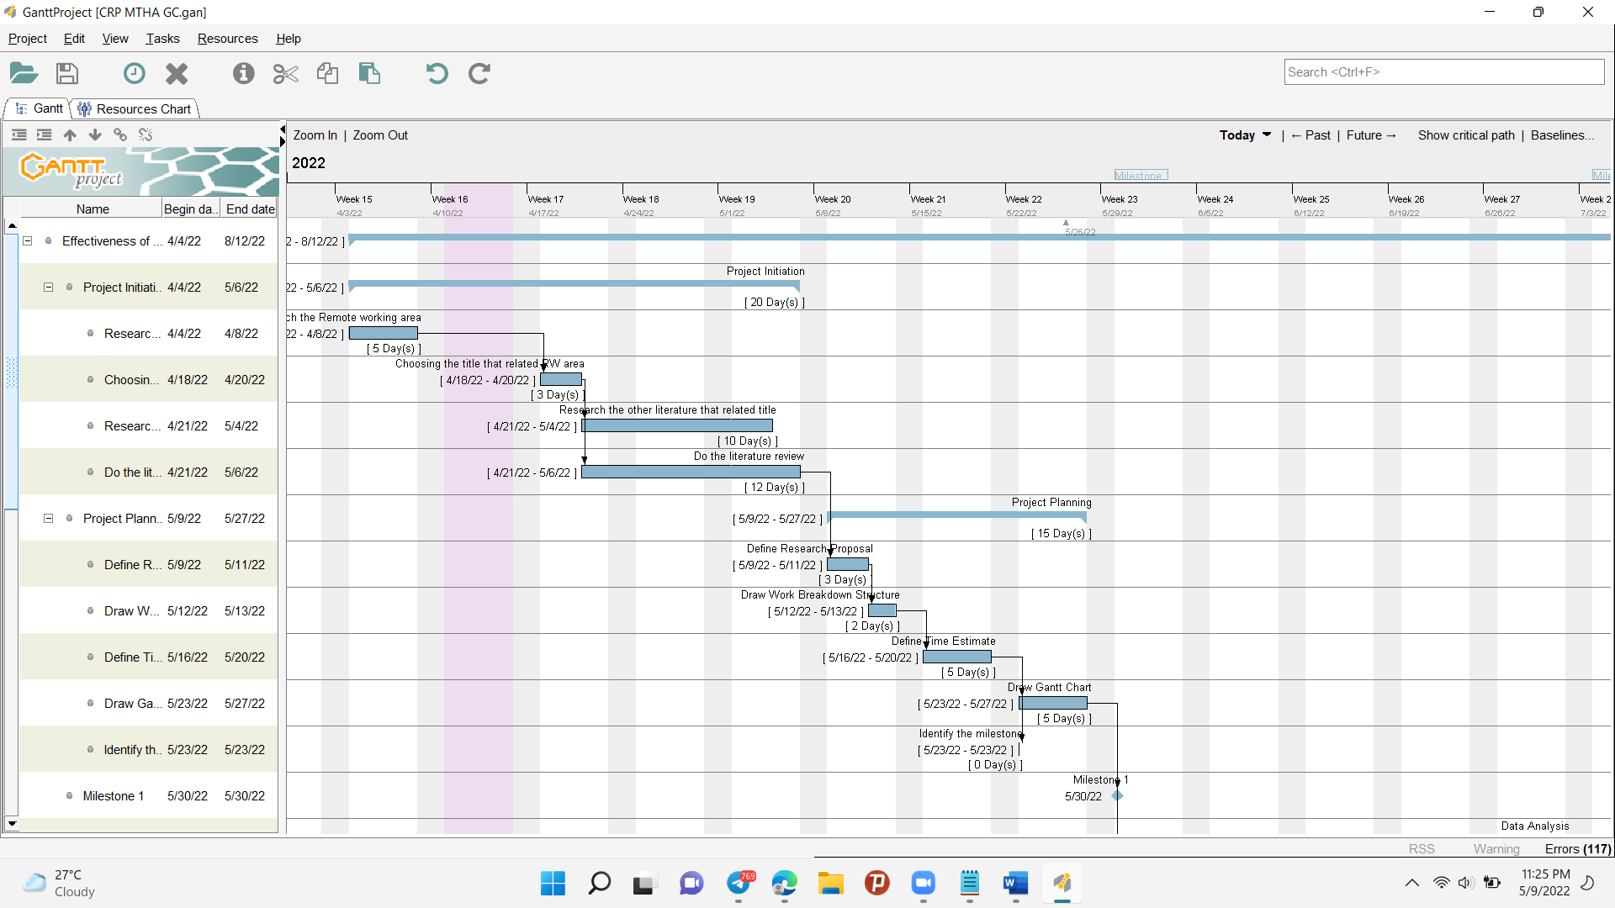

Fig (1.1) Project Initiation

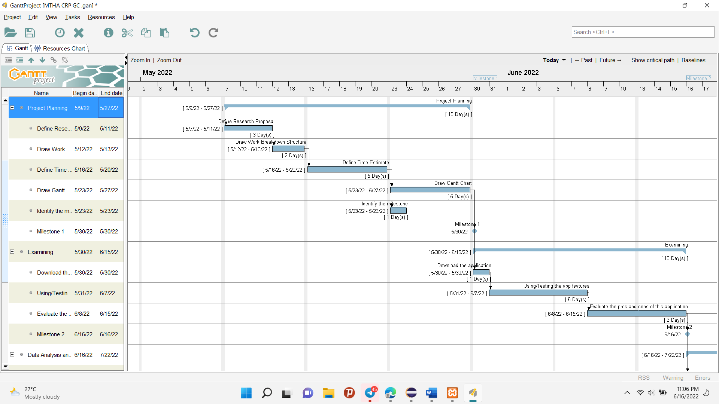

Fig (1.2) Project Planning

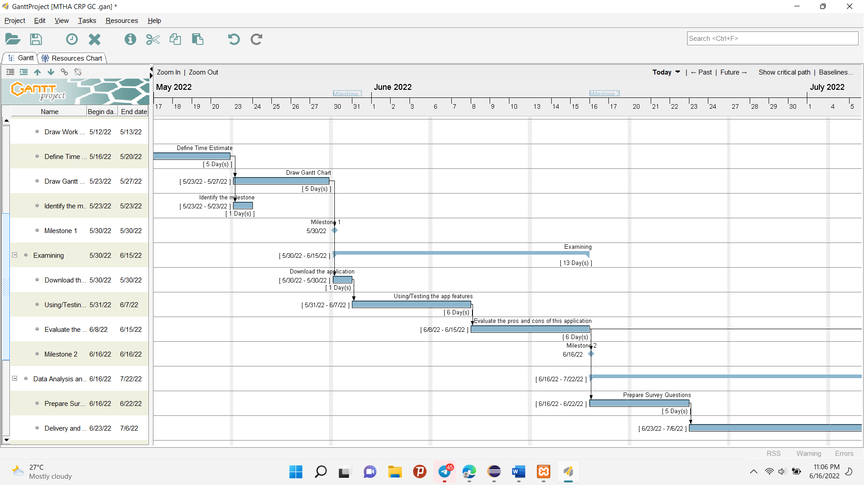

Fig (1.3) Examine

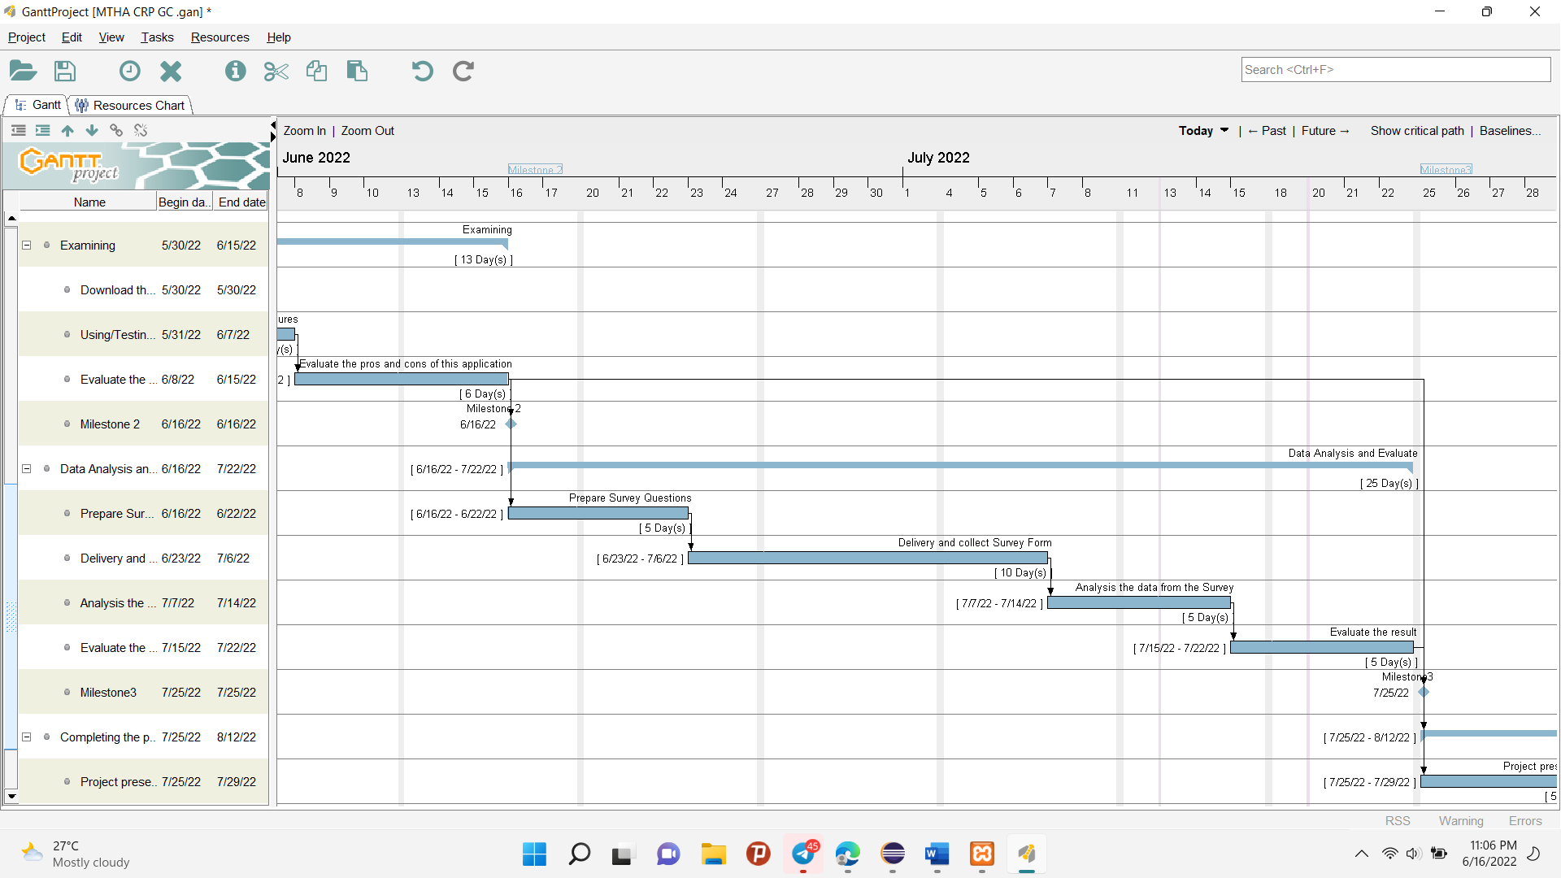

Fig (1.4) Data analysis and Evaluate

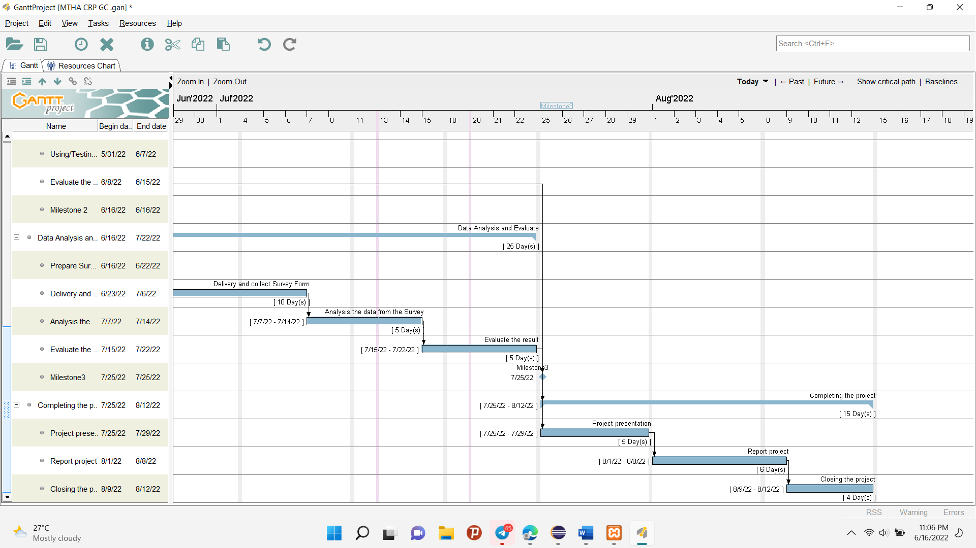

Fig (1.5) Completing the project

### Appendix 5

Research Ethics Approval Form

|  |
| --- |
| **Section One: Basic details**  Project title: Effectiveness of using Microsoft Teams in Online Education  Student name: May Thet Htar Aung  Student number: ...........................................................................................................................................  Programmed: HND (level 5)  School: Info Myanmar University  Intended research start date: 8. March.2022  Intended research end date: 12. Agust.2022 |
| **Section Two: Project summary**  Please select all research methods that you plan to use as part of your project:  • Interviews 🞎  • Questionnaires 🗹  • Observations 🞎  • Use of personal records 🞎  • Data analysis 🗹  • Action research 🞎  • Focus groups 🞎  • Other (please specify): ……………………………………………………………………………………. |

|  |
| --- |
| **Section Three: Participants**  Please answer the following questions, giving full details where necessary.  Will your research involve human participants?  Yes, this research will involve human participants.  Who are the participants? Tick all that apply:  Children aged 12–16: 🞎  Young people aged 17–18: 🗹  Adults: 🗹  How will participants be recruited (identified and approached)?  I used the non-probability sampling method to survey the research. In this non-probability sampling, I used the convenience method. Convenience Sampling is that subjects are selected because of their convenience, accessibility and proximity to the researcher. Fast, inexpensive, easy and the subjects are readily available.  Describe the processes you will use to inform participants about what you are doing:  I approached my participants who communicate with instant messages by using the social application then I explained in detail my research. Moreover, I delivered my senior and junior by giving a google form link. So, I explained in detail about the research upon the research form’s description.  How will you obtain consent from participants? Will this be written? How will it be made clear to participants that they may withdraw consent to participate at any time?  I did the consent about the survey from the participants. The was the writing letter record. In this writing letter combine that you can withdraw consent to participate at any time.  **Studies involving questionnaires:**  Will participants be given the option of omitting questions they do not wishto answer?  Yes: 🗹 No: 🞎  If No please explain why below and ensure that you cover any ethical issues arising from this:  **Studies involving observation:**  Confirm whether participants will be asked for their informed consent to be observed.  Yes: 🞎 No: 🗹  Will you debrief participants at the end of their participation (i.e., give them a brief explanation of the study)?  Yes: 🞎 No: 🗹  Will participants be given information about the findings of your study? (This could be a brief summary of your findings in general.)  Yes: 🗹 No: 🞎 |

|  |
| --- |
| **Section Four: Data storage and security**  Confirm that all personal data will be stored and processed in compliance with the Data Protection Act (1998):  Yes: 🗹 No: 🞎  Who will have access to the data and personal information?  The researcher and the researcher’s supervisors will have access to the data and personal information.  **During the research:**  Where will the data be stored?  The research data will be stored in Google drive and laptop.  Will mobile devices (such as USB storage and laptops) be used?  Yes: 🗹 No: 🞎  If yes, please provide further details:  In google drive, If you’ve got the Gmail address and password, you can get my survey. In laptop, I did the username and password to open my laptop. So, this all ways, I kept to secure my data.  **After the research:**  Where will the data be stored?  I will be stored the data in google drive and laptop.  How long will the data and records be kept for and in what format?  I will be kept the data for 6 months. And I will be use to kept the data by zipping method format.  Will data be kept for use by other researchers?  Yes: 🞎 No: 🗹  *If yes, please provide further details:* |
| **Section Five: Ethical issues**  **Informed consent**  I informed the process of my survey like the number of questions, not sharing your survey with others and you can withdraw consent to participate at any time. And then we did the consent with the writing letter.    **Potentially vulnerable participants**  In this research, I specified fifty participants to survey for my research. But according to my consent, participant will withdraw the consent. So, I should do survey above 60 participants.  **Confidentiality / anonymity**  According to consent, I will don’t share my participants’ survey with any others. I will do the name anonymity of my participants’ names.    **Data storage and security, both during and after the research (including transfer, sharing encryption, protection)**  I will store the data on google drive and laptops. That two all ways have the username and password. When I transfer my file, I will zip the file and encrypt the password to secure my data**.** |

|  |
| --- |
| **Section Six: Declaration**  I have read, understood and will abide by *[insert center name]* Research Ethics Policy:  Yes: 🗹 No: 🞎  I have discussed the ethical issues relating to my research with my Unit Tutor:  Yes: 🗹 No: 🞎  **I confirm that to the best of my knowledge:**  The above information is correct and that this is a full description of the ethics issues that may arise in the course of my research.  Name: May Thet Htar Aung  Date: 25. May.2022  **Please submit your completed form to:** Daw The Nandar Aung / Daw Khayea Aung |

### Appendix 6

Project Logbook -1

|  |
| --- |
| **Name: May Thet Htar Aung** |
| **Project title:**  **Effectiveness of Microsoft teams on online learning in remote working** |
| **Date:22.4.2022** |
| **Update on weekly research/tasks achieved**  **Points to consider:**  What have you completed?  This week, I chose the title for my research project on remote working.  Did you fulfil task requirements?  Yes, I fulfilled the task requirements.  Are you on track and within the deadlines set?  I guess that I am on track and within the deadlines set. But I need to have our supervisor look over what I'm doing for our project  Did you need to make any changes to your project management plan?  I guess that I am on track and within the deadlines set. But I need to have our supervisor look over what I'm doing for our project |
| **Any risks and/or issues identified?**  **Points to consider:**  Did you identify risks/issues with a lack of skills required for undertaking research/tasks?  This research on remote working is that I didn’t know what was the meaning. I always use it in this pandemic situation so I had to research many things and have chosen an interesting tile that was relating this area. I was using and studying many application-related remote working areas and testing what features.  Did you identify any additional risks/issues that have an impact on the project management plan?  When I downloaded many applications and tested them, my laptop often happened not to respond. That delayed my project management plan. |
| **Problems encountered**  **Points to consider:**  What barriers did you face?  While I was doing this research, my electricity was always off and then my internet connection was also down. That always happened every time.  How did you overcome them?  For this risk, I found a way to solve these problems. Firstly, I tried to do my research and homework when the electricity was on and then I used mobile data for internet connection. Whenever this way is not fine for the class time. Finally, I bought the inventor and battery to charge my devices and then plug the Fiber WIFI to get to the internet. |
| **New ideas and changes in project direction**  NO. |
| **What have I learned about myself this week?**  **Points to consider:**  How did I feel when I had to deal with tasks/problems?  While I started doing the research, I didn’t know well about remote working. So, I thought that it was a new area to research about it. By teaching and lecturing about that from the teacher and by researching online and eBooks about that, I had known well about that.  Did I find it useful to complete the tasks?  I found useful information to complete the tasks.  How well have I performed? What did I contribute?  I performed appropriately my project. My supervisor gives feedback when I did something wrong that time, I repair this feedback. I always try to finish my work on or ahead of the deadline. I try my best for my project.  What can I improve on next week?  Next week, I have to do a Literature review for my title project. So, I need to read, research, and summary from the other similar title project.  How might this learning apply in the future?  The project may be useful in the future. When we work, we already know how to manage our time, plan our projects, and research the information we need. |
| **Tasks planned for next week**  **Points to consider:**  Which tasks are a priority?  Next week, my priority task is to write a literature review for my project.  Have you set aside sufficient time for completion?  Yes, I have set aside sufficient time for completion. |
| **Project plan status to date (on, ahead, behind)**  Yes, I always do finish my work on the deadline. I didn’t want to annoy another person because of me. |
| **Supervisor comments to address** |
|  |

Project Logbook -2

|  |
| --- |
| **Name: May Thet Htar Aung** |
| **Project title:**  **Effectiveness of Microsoft teams on communication in remote working** |
| **Date:22.4.2022** |
| **Update on weekly research/tasks achieved**  **Points to consider:**  What have you completed?  This week, I research the other literature review that related my title and write the literature reviews. Moreover, I did the project proposal for my project. For project proposal, I did the Work Breakdown Structure, Time Estimation and Gantt Chart.  Did you fulfil task requirements?  Yes, I fulfilled the task requirements.  Are you on track and within the deadlines set?  I guess that I am on track and within the deadlines set. But I need to have our supervisor look over what I'm doing for our project  Did you need to make any changes to your project management plan?  I guess that I am on track and within the deadlines set. But I need to have our supervisor look over what I'm doing for our project |
| **Any risks and/or issues identified?**  **Points to consider:**  Did you identify risks/issues with a lack of skills required for undertaking research/tasks?  In this step, I researched many other source pages and websites that was related my title. That was one of the risks when doing literature reviews. Moreover, while doing project proposal, I had to do WBS, TE and GC. That are related each other. So, if the task in WBS changed, the other TE and GC are also changed. That all are my little issues in this task.  Did you identify any additional risks/issues that have an impact on the project management plan?  That all upper issues are delayed on my project management. If I did something wrong, that all are related each other so I had to change every step. |
| **Problems encountered**  **Points to consider:**  What barriers did you face?  While I was doing this research, my electricity was always off and then my internet connection was also down. That always happened every time.  How did you overcome them?  For this risk, I found a way to solve these problems. Firstly, I tried to do my research and homework when the electricity was on and then I used mobile data for internet connection. Whenever this way is not fine for the class time. Finally, I bought the inventor and battery to charge my devices and then plug the Fiber WIFI to get to the internet. |
| **New ideas and changes in project direction**  NO. |
| **What have I learned about myself this week?**  **Points to consider:**  How did I feel when I had to deal with tasks/problems?  While I started doing the research, I didn’t know well about remote working. So, I thought that it was a new area to research about it. By teaching and lecturing about that from the teacher and by researching online and eBooks about that, I had known well about that.  Did I find it useful to complete the tasks?  I found useful information to complete the tasks.  How well have I performed? What did I contribute?  I performed appropriately my project. My supervisor gives feedback when I did something wrong that time, I repair this feedback. I always try to finish my work on or ahead of the deadline. I try my best for my project.  What can I improve on next week?  Next week, I have to do an Analysis Data for my title project. So, I need to do Preparing Survey Forms, Delivery this survey to others, Evaluate the result and Analysis the data.  How might this learning apply in the future?  The project may be useful in the future. When we work, we already know how to manage our time, plan our projects, and research the information we need. |
| **Tasks planned for next week**  **Points to consider:**  Which tasks are a priority?  Next week, my priority task is to write Analysis Data for my project.  Have you set aside sufficient time for completion?  Yes, I have set aside sufficient time for completion. |
| **Project plan status to date (on, ahead, behind)**  Yes, I always do finish my work on the deadline. I didn’t want to annoy another person because of me. |
| **Supervisor comments to address** |
|  |

**Logbook 3**

|  |
| --- |
| **Name: May Thet Htar Aung** |
| **Project title:**  **Effectiveness of Microsoft teams on communication in remote working** |
| **Date:20.5.2022** |
| **Update on weekly research/tasks achieved**  **Points to consider:**  What have you completed?  This week, I did download the Microsoft Team Application. Moreover, I used and tested the application’s features and functions. Furthermore, I evaluated the pros and cons of these application for students to do online education.  Did you fulfil task requirements?  Yes, I fulfilled the task requirements.  Are you on track and within the deadlines set?  I guess that I am on track and within the deadlines set. But I need to have our supervisor look over what I'm doing for our project  Did you need to make any changes to your project management plan?  I guess that I am on track and within the deadlines set. But I need to have our supervisor look over what I'm doing for our project |
| **Any risks and/or issues identified?**  **Points to consider:**  Did you identify risks/issues with a lack of skills required for undertaking research/tasks?  In this step, I had a risk when I’m using and test the application, there had a little unfriendly of user interface.  Did you identify any additional risks/issues that have an impact on the project management plan?  For this upper risk, I searched the solution by searching the Guideline from YouTube how to use the Microsoft team application’s features. |
| **Problems encountered**  **Points to consider:**  What barriers did you face?  While I was doing this research, my electricity was always off and then my internet connection was also down. That always happened every time.  How did you overcome them?  For this risk, I found a way to solve these problems. Firstly, I tried to do my research and homework when the electricity was on and then I used mobile data for internet connection. Whenever this way is not fine for the class time. Finally, I bought the inventor and battery to charge my devices and then plug the Fiber WIFI to get to the internet. |
| **New ideas and changes in project direction**  NO. |
| **What have I learned about myself this week?**  **Points to consider:**  How did I feel when I had to deal with tasks/problems?  While I started doing the research, I didn’t know well about remote working. So, I thought that it was a new area to research about it. By teaching and lecturing about that from the teacher and by researching online and eBooks about that, I had known well about that.  Did I find it useful to complete the tasks?  I found useful information to complete the tasks.  How well have I performed? What did I contribute?  I performed appropriately my project. My supervisor gives feedback when I did something wrong that time, I repair this feedback. I always try to finish my work on or ahead of the deadline. I try my best for my project.  What can I improve on next week?  Next week, I have to present my presentation file to the supervisors.  How might this learning apply in the future?  The project may be useful in the future. When we work, we already know how to manage our time, plan our projects, and research the information we need. |
| **Tasks planned for next week**  **Points to consider:**  Which tasks are a priority?  Next week, my priority task is to find the solution that the effectiveness of using Microsoft team in online education by observing the survey from the others.  Have you set aside sufficient time for completion?  Yes, I have set aside sufficient time for completion. |
| **Project plan status to date (on, ahead, behind)**  Yes, I always do finish my work on the deadline. I didn’t want to annoy another person because of me. |
| **Supervisor comments to address** |
|  |

**Logbook 4**

|  |
| --- |
| **Name: May Thet Htar Aung** |
| **Project title:**  **Effectiveness of Microsoft teams on communication in remote working** |
| **Date:3.6.2022** |
| **Update on weekly research/tasks achieved**  **Points to consider:**  What have you completed?  This week, I did Google Survey Form for the project. So, I delivery this survey to related person. And then I collected the data from that survey. Moreover, I did First semester presentation file for this project.  Did you fulfil task requirements?  Yes, I fulfilled the task requirements.  Are you on track and within the deadlines set?  I guess that I am on track and within the deadlines set. But I need to have our supervisor look over what I'm doing for our project  Did you need to make any changes to your project management plan?  I guess that I am on track and within the deadlines set. But I need to have our supervisor look over what I'm doing for our project |
| **Any risks and/or issues identified?**  **Points to consider:**  Did you identify risks/issues with a lack of skills required for undertaking research/tasks?  In this step, I had a risk when I did the questions for the survey. I did carefully choose the question that would be related my hypothesis and research questions.  Did you identify any additional risks/issues that have an impact on the project management plan?  That all upper issues are delayed on my project management. If I did something wrong, that I’ll get the wrong data and unrelated data for my project. |
| **Problems encountered**  **Points to consider:**  What barriers did you face?  While I was doing this research, I got the fever because of the weather.  How did you overcome them?  For this risk, I drink the medicine to get over on time and ate the nutritious food. |
| **New ideas and changes in project direction**  NO. |
| **What have I learned about myself this week?**  **Points to consider:**  How did I feel when I had to deal with tasks/problems?  While I am doing this task, Firstly I prepared the questions to be consistent for my hypothesis. So, I had to discuss with the supervisors for a long time to get the best questionaries.  Did I find it useful to complete the tasks?  I found useful information to complete the tasks.  How well have I performed? What did I contribute?  I performed appropriately my project. My supervisor gives feedback when I did something wrong that time, I repair this feedback. I always try to finish my work on or ahead of the deadline. I try my best for my project.  What can I improve on next week?  Next week, I have to present my presentation file to the supervisors.  How might this learning apply in the future?  The project may be useful in the future. When we work, we already know how to manage our time, plan our projects, and research the information we need. |
| **Tasks planned for next week**  **Points to consider:**  Which tasks are a priority?  Next week, my priority task is to present my presentation file to the supervisors.  Have you set aside sufficient time for completion?  Yes, I have set aside sufficient time for completion. |
| **Project plan status to date (on, ahead, behind)**  This week, I did my work behind the deadline because of my health situation. |
| **Supervisor comments to address** |
|  |

|  |
| --- |
| **Name: May Thet Htar Aung**  **Logbook 5** |
| **Project title:**  **Effectiveness of Microsoft teams on communication in remote working** |
| **Date:17.6.2022** |
| **Update on weekly research/tasks achieved**  **Points to consider:**  What have you completed?  This week I also collected the data from people who I delivered the survey.  Did you fulfil task requirements?  Yes, I fulfilled the task requirements.  Are you on track and within the deadlines set?  I guess that I am on track and within the deadlines set. But I need to have our supervisor look over what I'm doing for our project  Did you need to make any changes to your project management plan?  I guess that I am on track and within the deadlines set. But I need to have our supervisor look over what I'm doing for our project |
| **Any risks and/or issues identified?**  **Points to consider:**  Did you identify risks/issues with a lack of skills required for undertaking research/tasks?  In this step, I hadn’t no risk. Because I waited and collect the data from those people.  Did you identify any additional risks/issues that have an impact on the project management plan?  I have nothing risk but I collected the correct and related data from my survey. |
| **Problems encountered**  **Points to consider:**  What barriers did you face?  This week, I am also recovering my health situation.  How did you overcome them?  This week I haven’t to do anything because I just waited the data from the delivered survey. So, I am trying to get well my health situation. |
| **New ideas and changes in project direction**  NO. |
| **What have I learned about myself this week?**  **Points to consider:**  How did I feel when I had to deal with tasks/problems?  While I started doing the research, I didn’t know well about remote working. So, I thought that it was a new area to research about it. By teaching and lecturing about that from the teacher and by researching online and eBooks about that, I had known well about that.  Did I find it useful to complete the tasks?  I found useful information to complete the tasks.  How well have I performed? What did I contribute?  I performed appropriately my project. My supervisor gives feedback when I did something wrong that time, I repair this feedback. I always try to finish my work on or ahead of the deadline. I try my best for my project.  What can I improve on next week?  Next week, I also have to collect data from surveys till limited.  How might this learning apply in the future?  The project may be useful in the future. When we work, we already know how to manage our time, plan our projects, and research the information we need. |
| **Tasks planned for next week**  **Points to consider:**  Which tasks are a priority?  Next week, my priority task is to collect data from surveys till limited.  Have you set aside sufficient time for completion?  Yes, I have set aside sufficient time for completion. |
| **Project plan status to date (on, ahead, behind)**  Yes, I always do finish my work on the deadline. I didn’t want to annoy another person because of me. |
| **Supervisor comments to address** |
|  |

**Logbook 6**

|  |
| --- |
| **Name: May Thet Htar Aung** |
| **Project title:**  **Effectiveness of Microsoft teams on communication in remote working** |
| **Date:1.7.2022** |
| **Update on weekly research/tasks achieved**  **Points to consider:**  What have you completed?  This week I also waited to fulfill the data from the survey till limited.  Did you fulfil task requirements?  Yes, I fulfilled the task requirements.  Are you on track and within the deadlines set?  I guess that I am on track and within the deadlines set. But I need to have our supervisor look over what I'm doing for our project  Did you need to make any changes to your project management plan?  I guess that I am on track and within the deadlines set. But I need to have our supervisor look over what I'm doing for our project |
| **Any risks and/or issues identified?**  **Points to consider:**  Did you identify risks/issues with a lack of skills required for undertaking research/tasks?  In this step, My survey didn't fulfil the data to a limit  Did you identify any additional risks/issues that have an impact on the project management plan?  So, I delivered the survey from the colleagues and friend with request paper . |
| **Problems encountered**  **Points to consider:**  What barriers did you face?  . While I was doing this research, my electricity was always off and then my internet connection was also down. That always happened every time.  How did you overcome them?  For this risk, I found a way to solve these problems. Firstly, I tried to do my research and homework when the electricity was on and then I used mobile data for internet connection. Whenever this way is not fine for the class time. Finally, I bought the inventor and battery to charge my devices and then plug the Fiber WIFI to get to the internet.  . |
| **New ideas and changes in project direction**  NO. |
| **What have I learned about myself this week?**  **Points to consider:**  How did I feel when I had to deal with tasks/problems?  While I am doing this task, I got the problem that is didn’t fulfil the amount of data from the survey. So, I delivered the survey with the request paper to my colleagues.  Did I find it useful to complete the tasks?  I found useful information to complete the tasks.  How well have I performed? What did I contribute?  I performed appropriately my project. My supervisor gives feedback when I did something wrong that time, I repair this feedback. I always try to finish my work on or ahead of the deadline. I try my best for my project.  What can I improve on next week?  Next week, I also have to collect data from surveys till limited.  How might this learning apply in the future?  The project may be useful in the future. When we work, we already know how to manage our time, plan our projects, and research the information we need. |
| **Tasks planned for next week**  **Points to consider:**  Which tasks are a priority?  Next week, my priority task is to do data analysis for my survey but I need to wait to get enough data.  Have you set aside sufficient time for completion?  Yes, I have set aside sufficient time for completion. |
| **Project plan status to date (on, ahead, behind)**  I didn’t finish my task on head because I need to wait to get enough data from my survey. |
| **Supervisor comments to address** |
|  |

|  |
| --- |
| **Name: May Thet Htar Aung**  Logbook 7 |
| **Project title:**  **Effectiveness of Microsoft teams on communication in remote working** |
| **Date:15.7.2022** |
| **Update on weekly research/tasks achieved**  **Points to consider:**  What have you completed?  This week I did the data analysis for my survey.  Did you fulfil task requirements?  Yes, I fulfilled the task requirements.  Are you on track and within the deadlines set?  I guess that I am on track and within the deadlines set. But I need to have our supervisor look over what I'm doing for our project  Did you need to make any changes to your project management plan?  I guess that I am on track and within the deadlines set. But I need to have our supervisor look over what I'm doing for our project |
| **Any risks and/or issues identified?**  **Points to consider:**  Did you identify risks/issues with a lack of skills required for undertaking research/tasks?  In this step, I had some risks to analysis my data. Because there have so many confusion data for my survey.  Did you identify any additional risks/issues that have an impact on the project management plan?  I solved this problem to do data analysis by using the ANOVA, Reliability and Validity, and Regression Analysis. |
| **Problems encountered**  **Points to consider:**  What barriers did you face?  While I was doing this research, my electricity was always off and then my internet connection was also down. That always happened every time.  How did you overcome them?  For this risk, I found a way to solve these problems. Firstly, I tried to do my research and homework when the electricity was on and then I used mobile data for internet connection. Whenever this way is not fine for the class time. Finally, I bought the inventor and battery to charge my devices and then plug the Fiber WIFI to get to the internet. |
| **New ideas and changes in project direction**  NO. |
| **What have I learned about myself this week?**  **Points to consider:**  How did I feel when I had to deal with tasks/problems?  While I started doing the data analysis for my survey, I didn’t know about the data analysis. So, our supervisor explained how to do data analysis and provided the list of the data analysis types. At that time, I felt like I relief.  Did I find it useful to complete the tasks?  I found useful information to complete the tasks.  How well have I performed? What did I contribute?  I performed appropriately my project. My supervisor gives feedback when I did something wrong that time, I repair this feedback. I always try to finish my work on or ahead of the deadline. I try my best for my project.  What can I improve on next week?  Next week, I also have to collect data from surveys till limited.  How might this learning apply in the future?  The project may be useful in the future. When we work, we already know how to manage our time, plan our projects, and research the information we need. |
| **Tasks planned for next week**  **Points to consider:**  Which tasks are a priority?  Next week, my priority task is to finish the data analysis.  Have you set aside sufficient time for completion?  Yes, I have set aside sufficient time for completion. |
| **Project plan status to date (on, ahead, behind)**  Yes, I always do finish my work on the deadline. I didn’t want to annoy another person because of me. |
| **Supervisor comments to address** |
|  |

|  |
| --- |
| **Name: May Thet Htar Aung**  **Logbook 8** |
| **Project title:**  **Effectiveness of Microsoft teams on communication in remote working** |
| **Date:29.7.2022** |
| **Update on weekly research/tasks achieved**  **Points to consider:**  What have you completed?  This week I also did the data analysis for my survey.  Did you fulfil task requirements?  Yes, I fulfilled the task requirements.  Are you on track and within the deadlines set?  I guess that I am on track and within the deadlines set. But I need to have our supervisor look over what I'm doing for our project  Did you need to make any changes to your project management plan?  I guess that I am on track and within the deadlines set. But I need to have our supervisor look over what I'm doing for our project |
| **Any risks and/or issues identified?**  **Points to consider:**  Did you identify risks/issues with a lack of skills required for undertaking research/tasks?  In this step, I had some risks to analysis my data. Because there have so many confusion data for my survey.  Did you identify any additional risks/issues that have an impact on the project management plan?  I solved this problem to do data analysis by using the ANOVA, Reliability and Validity, and Regression Analysis. |
| **Problems encountered**  **Points to consider:**  What barriers did you face?  While I was doing this research, my electricity was always off and then my internet connection was also down. That always happened every time.  How did you overcome them?  For this risk, I found a way to solve these problems. Firstly, I tried to do my research and homework when the electricity was on and then I used mobile data for internet connection. Whenever this way is not fine for the class time. Finally, I bought the inventor and battery to charge my devices and then plug the Fiber WIFI to get to the internet. |
| **New ideas and changes in project direction**  NO. |
| **What have I learned about myself this week?**  **Points to consider:**  How did I feel when I had to deal with tasks/problems?  While I started doing the data analysis for my survey, I didn’t know about the data analysis. So, our supervisor explained how to do data analysis and provided the list of the data analysis types. At that time, I felt like I relief.  Did I find it useful to complete the tasks?  I found useful information to complete the tasks.  How well have I performed? What did I contribute?  I performed appropriately my project. My supervisor gives feedback when I did something wrong that time, I repair this feedback. I always try to finish my work on or ahead of the deadline. I try my best for my project.  What can I improve on next week?  Next week, I have to do reflective for my project and report about the project performance.  How might this learning apply in the future?  The project may be useful in the future. When we work, we already know how to manage our time, plan our projects, and research the information we need. |
| **Tasks planned for next week**  **Points to consider:**  Which tasks are a priority?  Next week, my priority task is to do reflective for my project and report about the project performance  Have you set aside sufficient time for completion?  Yes, I have set aside sufficient time for completion. |
| **Project plan status to date (on, ahead, behind)**  Yes, I always do finish my work on the deadline. I didn’t want to annoy another person because of me. |
| **Supervisor comments to address** |
|  |

**Logbook 9**

|  |
| --- |
| **Name: May Thet Htar Aung** |
| **Project title:**  **Effectiveness of Microsoft teams on communication in remote working** |
| **Date:29.7.2022** |
| **Update on weekly research/tasks achieved**  **Points to consider:**  What have you completed?  This week I did project performance by using reflective writing.  Did you fulfil task requirements?  Yes, I fulfilled the task requirements.  Are you on track and within the deadlines set?  I guess that I am on track and within the deadlines set. But I need to have our supervisor look over what I'm doing for our project  Did you need to make any changes to your project management plan?  I guess that I am on track and within the deadlines set. But I need to have our supervisor look over what I'm doing for our project |
| **Any risks and/or issues identified?**  **Points to consider:**  Did you identify risks/issues with a lack of skills required for undertaking research/tasks?  In this task, I haven’t many risks but I had to choose the reflective methods for my project performance.  Did you identify any additional risks/issues that have an impact on the project management plan?  But I listened our supervisor’s recommendations which methods is the most effective for my project performance. |
| **Problems encountered**  **Points to consider:**  What barriers did you face?  While I was doing this research, my electricity was always off and then my internet connection was also down. That always happened every time.  How did you overcome them?  For this risk, I found a way to solve these problems. Firstly, I tried to do my research and homework when the electricity was on and then I used mobile data for internet connection. Whenever this way is not fine for the class time. Finally, I bought the inventor and battery to charge my devices and then plug the Fiber WIFI to get to the internet. |
| **New ideas and changes in project direction**  NO. |
| **What have I learned about myself this week?**  **Points to consider:**  How did I feel when I had to deal with tasks/problems?  While I am doing the project performance task, I didn’t happen many problems.  Did I find it useful to complete the tasks?  I found useful information to complete the tasks.  How well have I performed? What did I contribute?  I performed appropriately my project. My supervisor gives feedback when I did something wrong that time, I repair this feedback. I always try to finish my work on or ahead of the deadline. I try my best for my project.  What can I improve on next week?  Next week, I have to finish reflective for my project and report about the project performance.  How might this learning apply in the future?  The project may be useful in the future. When we work, we already know how to manage our time, plan our projects, and research the information we need. |
| **Tasks planned for next week**  **Points to consider:**  Which tasks are a priority?  Next week, my priority task is to do reflective for my project and report about the project performance  Have you set aside sufficient time for completion?  Yes, I have set aside sufficient time for completion. |
| **Project plan status to date (on, ahead, behind)**  Yes, I always do finish my work on the deadline. I didn’t want to annoy another person because of me. |
| **Supervisor comments to address** |
|  |

### Appendix 7

Performance Review

My project title is the Effectiveness of using Microsoft Teams in online learning.This project is aimed at online learning students. In this pandemic situation, most of the students and employees are running the routine daily work based on the online. So, we all are widely using various kinds of a remote working applications. But I just want to use the Microsoft Teams Application for students in remote working. I want to prove that this app has various kinds of features and functions that are effective for the student in remote learning. My accomplish and hypothesis is Microsoft Teams have the good features which can have positively effects for students in remote working. I guessed my project is succeeded in its aim. Because when I did the questionaries survey , I got the data and information for my questionaries. After that, I did data analysis for each question. Over 50% of people are agree with my study.

For this project, I worked well on these 5 steps. That is the project initiation, Project planning, Data Analysis, Examining and Completing the project. Each task has other tasks. So, I will explain this all tasks and how to work well by using Kolb’s learning cycle in reflective writing.

The first step of Kolb's learning cycle is Experience. In this project, I worked on many things. During the project initiation, I did Research on the remote working area, Chose the title that related RW area, researched the other literature that related to my title and do the literature review. In those task, I researched about many remote working area and chose the title for my project. After that, I had to do the literature review for my project related title. I didn’t know about how to do literature review but I did well by our supervisors’ help and from the other literature review. In the project planning task, I did the project proposal after literature review. At that time , I already known well what is my project’s aim and objectives. Then I did the time management and dividing the task by using Work Breakdown Structure, Time estimation and Gantt Chart. In this Gantt , I divided the milestones for the project. While doing this tasks, I prepare many times to match the estimated time with the tasks. In this examining tasks, I tested my application and then evaluated what is the pros and cons of this applications. Moreover, I also did Prepare Survey Question, Delivery Survey form, Analysis the data from the Survey and Evaluate the result. And then in the data analysis tasks, I prepared the questionaries and delivered the survey to the friendly technology colleagues and friends. All done this project tasks, I did the analysis for my project. Most of the people are giving the positive feedbacks of my research project. And they point out what is the requirement of this application for the online education students. When we add the requirements, this application is perfect and effective for online learning students. The final task is completing the project . But it didn’t finish yet. Now I’m doing project performance for the whole project by using Kolb’s learning cycle reflective writing.

The second step of Kolb’s learning cycle is reflective . While I am doing this project, I didn’t know about the remote working although I was using it. In this project Initiation tasks, I got many knowledge from the remote working area. After that, I thought the aim and objectives for my project in a short time. That was really stressed me out. But I overcame by our supervisor’s help. And then I did time management by using those of things. But those things are friendly in MSCP subject so I didn’t have many problems. After that I did the testing my chosen application , but this application is already friendly with me so I already known about what is pros and cons for students. Thus, in this examining task, I didn’t have many obstacles. Furthermore, In this data analysis task, I did many times to get the right questionaries and to match with my hypothesis. I gave a long time than I expected. And then, I did the data analysis for my collected data by using many analysis methods. After the analysis, I got the answers that I expected.

The third step of Kolb’s learning cycle is a conceptualize. In this project initiation , planning and data analysis tasks, I got the many obstacles and didn’t match with my time management. Cause of my country situation, my personal cases and health cases. So next time, I need to estimate exactly my time while doing my project. While doing data analysis, I thought many methods for each tasks. Some methods are fine but some of them are not reliable so that my supervisors gave me the tips what should I use which method is fine for each questions. And then I got the answer from the analysis, over 50% are agreeing with my hypothesis. So, I need to do that questionaries must be to match with the hypothesis.

The final step of Kolb’s learning cycle is Plan. This research project is so effective for my future projects. I got the many obstacles and knowledges how to start and how to end to get effectively research for project. The main aim of this project is the effectiveness of using Microsoft Teams in online learning. Some of them are giving me the suggestion to know the requirements of this application. So that I can fix this requirements to be effectiveness .

I gave 4 out of 5 for my performance as a project manager. Because I try my best while doing the whole project. Other 1 is that I also had some personal cases and project’s obstacles. The strength of my performance is I did try my best all of the tasks. I tried to match the time management as much as possible. As the supervisors suggested, I made each task as similar as possible. My weakness of my performance is that while I’m doing this project, I had a little health cases and personal cases. And then when I am doing this data analysis, I need to study various types of analysis methods. This research project is so effective for my continuous professional development. Next time if I have a chance to develop this app’s requirement features, I want to do development.

